

Project-based Practical Report on

Gym Management System

Submitted in partial fulfilment of the requirements for “Data Structures and Algorithmic Techniques” for the 1st Semester

Master of Computer Applications (MCA)

Submitted by

Rahul Raj 26MCAB57

Under the guidance of

Contents
1. Abstract
2. Introduction
3. Objective of the Project
4. Scope of the Project
5. Software Specifications
6. Workflow of the Project
7. Modules of the Project - Phase-wise explanation of design and execution of Modules
8. Source Code (Only functional code structure)
9. Features of the Project
10. Future Enhancements
11. Conclusion

1. Title of the Project
Pro-Fitness Gym Management System – a Data Structures and Algorithms project developed in Java using Servlets and JSP, in which a linked list, stack, queue, binary tree, binary search tree and graph, together with searching, sorting, greedy, dynamic programming and backtracking algorithms, are applied to the operations of a gym.
1.1 Abstract
This project presents the Pro-Fitness Gym Management System, a Java web application developed with Servlets and JSP to demonstrate the practical use of core data structures and algorithmic techniques. The gym domain is used because its daily operations, such as managing members, tracking check-ins, queuing trainer appointments, organising workout plans, navigating gym zones, searching and sorting records, and scheduling trainers, map directly to well-known data structure and algorithm problems.
The system implements a singly linked list for member records with insert, find, update and delete operations; a stack for member check-in and check-out; a queue for trainer appointment requests; a binary tree for the hierarchy of workout plans with pre-order, in-order and post-order traversals; a binary search tree for member look-up by ID; and an adjacency-list graph of gym zones with breadth-first and depth-first traversals. The first five of these structures are built from node classes and references that are written from scratch. Linear search and binary search, together with insertion sort and merge sort, are applied to the member list and are compared using the number of comparisons and the measured running time. A greedy activity-selection algorithm schedules trainer sessions, a dynamic programming 0/1 knapsack selects the best exercises for a given time limit, and a backtracking algorithm assigns members to trainers under specialisation and time-slot constraints. A stack-based validator checks the brackets of a formula.
Every module shows the steps that the algorithm performs, so the application can also be used to explain how each data structure and algorithm works. The in-memory structures are loaded from CSV files when the server starts and are saved back after each change. The result is a complete, menu-driven web application that connects theory to a realistic use case.

2. INTRODUCTION

2.1 Background
A data structure is a systematic way of organising data in the memory of a computer so that it can be stored, accessed and modified efficiently. An algorithm is a finite, well-defined sequence of steps that works on that data to solve a problem. Every useful software system, from an online shopping site to a hospital register, is built on a careful choice of data structures and algorithms. A wrong choice makes a program slow or hard to maintain, while a correct choice makes the same program fast and simple.
A gym is a good everyday example of an environment that produces a continuous stream of changing data. New members join and old members leave, people enter and leave the floor throughout the day, members ask for personal-training sessions with a particular trainer, workouts are grouped into categories, the floor is divided into connected zones, and trainers must be scheduled so that two sessions never overlap. Each of these day-to-day activities can be modelled naturally with a specific data structure or solved with a specific algorithm. This observation is the foundation of the project described in this document.

2.2 About the Project
The Pro-Fitness Gym Management System is a web-based application developed in Java using Servlets and JavaServer Pages (JSP). It was built for the course Data Structures and Algorithm as a project of four mandatory phases. The application is not only a gym management tool; it is also a working demonstration of how the data structures and algorithms taught in the course are used in a real, connected application.
The singly linked list, stack, queue, binary tree and binary search tree of the project are written from scratch using node classes and references, and the graph is stored as an adjacency list. The searching, sorting, greedy, dynamic programming and backtracking algorithms are also written by hand and do not call the library sorting or searching methods. The application runs on an Apache Tomcat server, shows every module on its own web page, and stores its records in simple CSV files so that the data is available again when the server is restarted.

2.3 Mapping of Gym Operations to Data Structures
The central idea of the project is that each gym operation is handled by the data structure that suits it best. Table 1 summarises this mapping, and each row is explained in detail in the module description (Section 7).
Table 1: Mapping of gym operations to data structures and algorithms
Gym operation | Data structure / algorithm used | Reason for the choice
Registering, updating and removing members | Singly Linked List | Members join and leave at any time; a linked list grows and shrinks without shifting data.
Members currently on the gym floor | Stack (built with linked nodes) | The most recent check-in is the first one handled on check-out (Last In, First Out).
Personal-trainer appointment requests | Queue (built with linked nodes) | Requests must be processed in the order they arrive (First In, First Out).
Workout plan categories | Binary Tree | Categories form a natural hierarchy (plan, type, body part).
Fast member look-up by ID | Binary Search Tree | Each comparison discards one whole branch of the tree.
Connected gym zones | Graph (adjacency list) with BFS and DFS | Zones are connected by paths in both directions.
Finding a member and ordering the member list | Linear Search, Binary Search, Insertion Sort, Merge Sort | Compares simple and efficient techniques on the same data.
Trainer scheduling | Greedy algorithm (activity selection) | Choosing the session that finishes earliest leaves most room for others.
Choosing exercises for a limited time | 0/1 Knapsack (dynamic programming) | Maximises fitness value without exceeding the time budget.
Matching members to trainers | Backtracking | Constraints (specialisation and time slot) may force earlier choices to be undone.
Checking brackets in a formula | Stack application | The most recent opening bracket must be closed first.

3. OBJECTIVE OF THE PROJECT

3.1 Main Objective
The main objective of the project is to design and develop a working Gym Management System in which each major operation is implemented with the most suitable data structure or algorithm, so that the theory learned in the Data Structures and Algorithm course is applied in a complete, integrated application.

3.2 Specific Objectives
- To implement a singly linked list for dynamic storage of member records and to perform insert, find, update and delete operations on it.
- To implement a stack using linked nodes for tracking member check-in and check-out, and to apply a stack to a simple problem, namely bracket validation of a formula.
- To implement a queue using linked nodes for managing trainer appointment requests in the order of arrival.
- To implement a binary tree for the hierarchy of workout plans and to perform pre-order, in-order and post-order traversals.
- To implement a binary search tree for efficient access to member records by member ID, including insertion, search and deletion.
- To represent the gym zones as a graph using an adjacency list and to perform breadth-first and depth-first traversals.
- To implement linear search and binary search, to implement insertion sort and merge sort, and to use sorting and searching inside the member workflow.
- To compare the algorithms by the number of comparisons and the running time in order to build a basic understanding of efficiency.
- To apply a greedy technique (activity selection) for trainer scheduling, dynamic programming (0/1 knapsack) for exercise selection, and backtracking for trainer-member assignment.
- To integrate all modules into one web application with a common data store and to demonstrate the different algorithm use cases.

3.3 Learning Objectives
- To understand how nodes and references are used to build dynamic structures.
- To understand the difference between Last In First Out and First In First Out behaviour.
- To understand how the shape of a tree affects the cost of searching.
- To understand why binary search needs sorted data, and how much work it saves.
- To understand the difference between a greedy choice, an optimal solution found through a table, and a solution found by trying and undoing choices.

4. SCOPE OF THE PROJECT
The system is intended for a gym administrator who manages the gym from a single web interface. Its scope covers the following areas:
- Member management: registering, finding, updating and deleting member records.
- Session tracking: checking members in and out of the gym floor.
- Trainer appointments: recording and processing personal-training requests in arrival order.
- Visualisation of the workout-plan hierarchy, the member search tree and the gym zone layout through the three tree traversals and the two graph traversals.
- A search and sort laboratory that compares two search methods and two sorting methods on the real member list.
- An algorithm laboratory that runs a greedy scheduler, a knapsack optimiser and a backtracking assigner and shows each step.
- A bracket validator that demonstrates a stack-based application.
The workout-plan hierarchy and the zone layout of the gym are built into the application as fixed examples, and the application does not include a user login. These boundaries keep the project focused on the data structures and algorithms that are the subject of the course.

5. SOFTWARE SPECIFICATIONS
This section lists what the system must do and what is needed to build and run it. The functional requirements are taken from the modules that are present in the application.

5.1 Functional Requirements
Table 2: Functional requirements
ID | Requirement | Module
FR1 | The system shall register a new member with ID, name, membership type and fee status, and shall reject an ID that already exists. | Member Management
FR2 | The system shall find a member by ID, update the details of a member and delete a member. | Member Management
FR3 | The system shall check a registered member in, refuse a second check-in of the same member, and check out the most recent check-in. | Session Tracking
FR4 | The system shall accept a trainer appointment request for a registered member and process pending requests in arrival order. | Trainer Appointments
FR5 | The system shall display the workout-plan hierarchy and show its pre-order, in-order and post-order traversals with the steps. | Workout Plans
FR6 | The system shall search a member by ID in a binary search tree and show the path and the number of comparisons; the tree can be rebuilt from the member list. | BST Member Lookup
FR7 | The system shall show the gym zones as an adjacency list and perform BFS and DFS from a chosen zone with the steps. | Zone Navigation
FR8 | The system shall search a member with linear search and binary search (after sorting) and compare comparisons and time. | Search and Sort Lab
FR9 | The system shall sort the member list with insertion sort and merge sort and compare the two methods. | Search and Sort Lab
FR10 | The system shall schedule training sessions to a chosen number of trainers (1 to 5) using a greedy algorithm and list the unscheduled sessions. | Algorithm Lab
FR11 | The system shall select the best set of exercises for a given time limit using the 0/1 knapsack algorithm. | Algorithm Lab
FR12 | The system shall assign members to trainers by specialisation and time slot using backtracking and report members that cannot be assigned. | Algorithm Lab
FR13 | The system shall validate the brackets of a formula using a stack and report the position of an error. | Expression Validator
FR14 | The system shall keep members, check-ins and appointments in CSV files and reload them when the server starts. | Data Management

5.2 Non-Functional Requirements
- Usability: every module has its own page with forms, tables, success messages and error messages, so a user can operate the system without training.
- Transparency: each algorithm returns a list of steps that is displayed on the page, so the working of the algorithm can be followed.
- Maintainability: the data structures and algorithms are kept in a separate package (com.profitness.dsa) that does not depend on the web classes, while the servlets in com.profitness.web only call them.
- Persistence: records are written to CSV files after each change and are read again at start-up.
- Portability: the application is packaged as a WAR file and runs on any machine that has a Java 17 runtime and Apache Tomcat 10.1.
- Thread safety of the shared store: the data store is a singleton and its load and save methods are synchronised, because several browser requests may reach the server together.

5.3 Hardware Requirements
The application is light-weight and does not need special hardware. The configuration in the table below is the recommended minimum for developing and running the project.
Table 3: Hardware requirements
Component | Requirement
Processor | Dual-core processor, 2 GHz or higher
Main memory (RAM) | 4 GB or more (8 GB recommended while the IDE, Tomcat and browser run together)
Storage | At least 1 GB of free disk space for the JDK, Maven repository, Tomcat and the project
Display | 1366 x 768 resolution or higher
Input devices | Keyboard and mouse
Network | Not required to run the application locally. An internet connection is needed only to load the web fonts and icons used by the pages and to download Maven dependencies.

5.4 Software Requirements
Table 4: Software requirements
Software | Details
Operating system | Any operating system that supports Java 17 and Apache Tomcat 10.1 (for example Windows, Linux or macOS)
Programming language | Java, release 17 (set as the compiler source and target in the Maven build)
Server-side technology | Jakarta Servlet API 6.0 and Jakarta Server Pages 3.1 (JSP) with JSTL 3.0
Application server | Apache Tomcat 10.1 (Jakarta EE 10)
Build tool | Apache Maven, packaging type WAR, final file name ProFitnessGym.war
Front end | HTML5, CSS3 and JavaScript (style.css and app.js); Google Fonts and Font Awesome 6.5.1 are loaded from their content delivery networks
Data storage | Comma-separated value (CSV) files in the data folder
Web browser | Any modern web browser, for example Google Chrome or Microsoft Edge
Development environment | ______________________ (to be filled in by the student: IDE or editor used)

5.5 Technology Stack Summary
Table 5: Technology stack
Layer | Technology | Role in the project
Presentation | JSP, JSTL, HTML, CSS, JavaScript | 10 pages: home page and one page for each module; style.css gives the dark theme with orange and cyan accents; app.js provides navigation, tabs, counters and alert messages.
Controller | Java Servlets (Jakarta Servlet 6.0) | 8 servlets read the request parameter "action", call the data structures and forward the result to the JSP page.
Data structures and algorithms | Core Java (package com.profitness.dsa) | 30 classes containing all nodes, data structures, algorithms and result objects.
Shared store | Java singleton class DataStore and AppInitListener | Creates and keeps the in-memory structures, loads and saves the CSV files, and is started when the server starts.
Storage | CSV files | members.csv, checkins.csv and appointments.csv.
Build and deployment | Maven (WAR) and Apache Tomcat 10.1 | Builds ProFitnessGym.war and serves the application.

The Maven file declares the Jakarta Servlet API 6.0.0 and the Jakarta JSP API 3.1.1 with the scope "provided", because Tomcat supplies them at run time, and the JSTL implementation 3.0.1 with its API 3.0.0, which are packaged inside the WAR file.

6. WORKFLOW OF THE PROJECT

6.1 Overview
The proposed system is a web application with one home page and nine module pages, each of which demonstrates one data structure or algorithm on gym data. The administrator opens the application in a browser, chooses a module from the navigation menu, enters data in a form, and sees the result together with the steps of the algorithm that produced it.
Behind the pages, the application keeps all records in main memory in the data structures that the course teaches. When a record is added, changed or removed, the matching structure is updated first and the CSV file is written afterwards. When the server is started again, the CSV files are read and the structures are rebuilt.

6.2 System Architecture
The application is organised in layers, as shown in Figure 1. Each layer has one responsibility and talks only to the layer next to it.
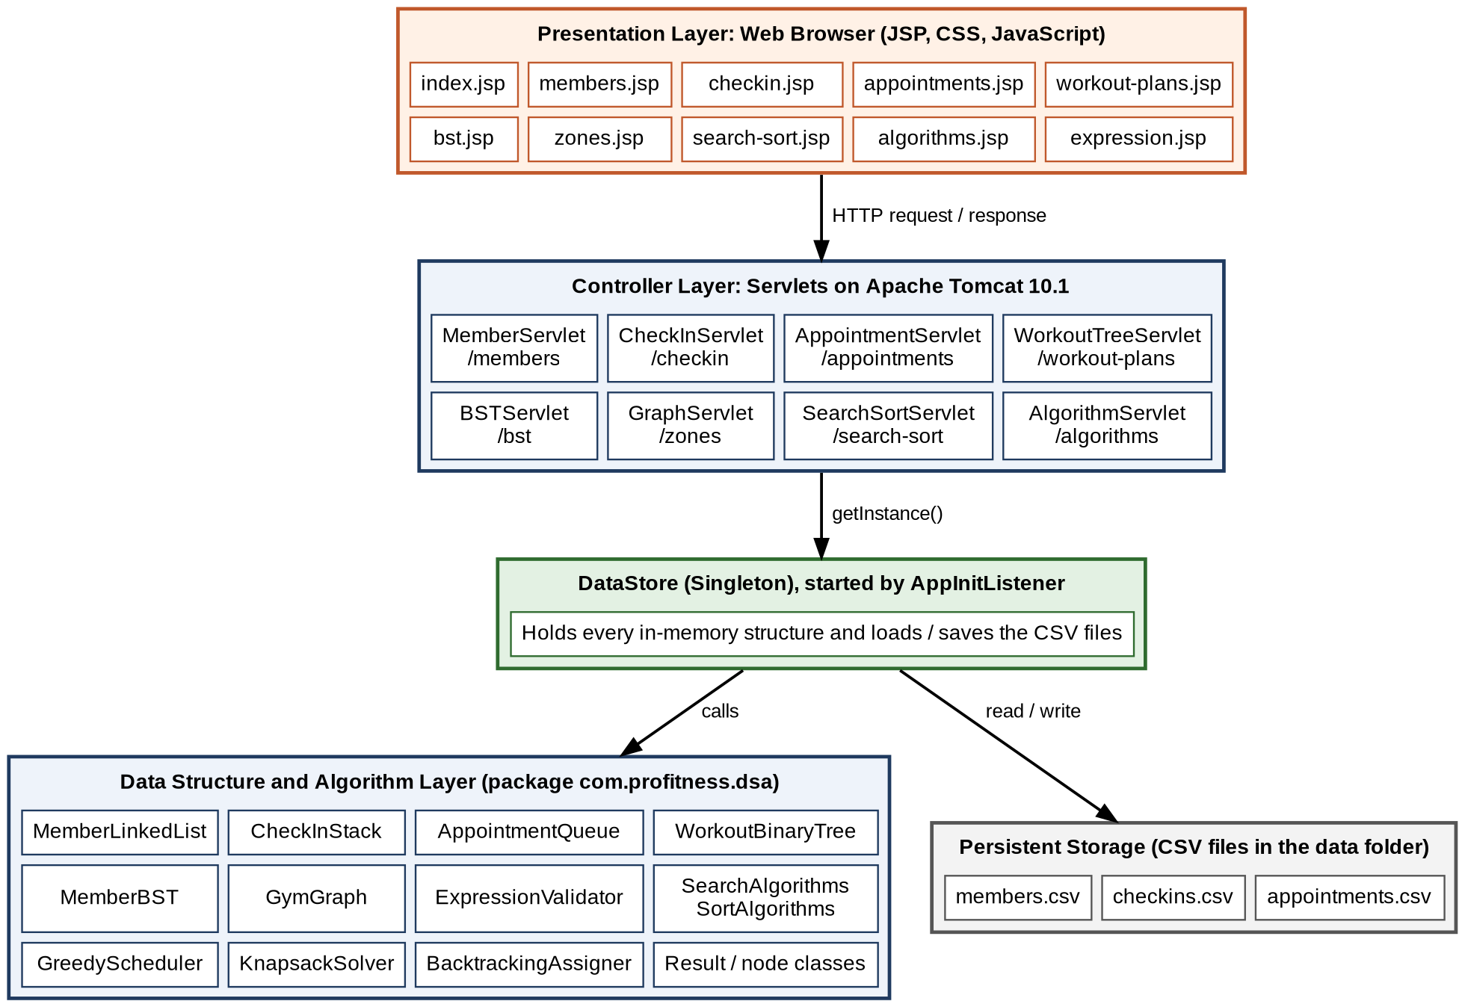
Figure 1: Layered architecture of the Pro-Fitness Gym Management System
- Presentation layer: the ten JSP pages and the supporting style sheet and JavaScript file. The pages display the data that the servlets place in the request.
- Controller layer: eight servlets, one for each functional page. A servlet reads the request parameter named action, calls the data structure, and then forwards to the page or redirects with a message.
- DataStore: a singleton object that creates and holds one instance of every data structure. All servlets obtain the same instance, so every page sees the same data.
- Data structure and algorithm layer: the package com.profitness.dsa, which contains the data structures, the algorithms and the result objects. It has no dependency on the web classes, so it can be tested on its own.
- Storage layer: three CSV files in the data folder.

6.3 Request Processing Flow
Every user action follows the same path through the layers. The steps are shown below for an operation that changes data, for example registering a member.
- The user fills a form in the browser and submits it. The form sends an HTTP POST request with the field values and an action value to the servlet of that module.
- The servlet reads the action value in doPost, validates the fields and converts the text to numbers where needed.
- The servlet obtains the DataStore singleton and calls the method of the data structure, for example addMember on the linked list.
- If the operation succeeds, the servlet also updates any related structure (the member BST is updated after the linked list) and asks the DataStore to save the CSV file.
- The servlet redirects the browser to its own page with a success or error message in the address. For read-only actions such as searching or traversing, it forwards to the JSP page with the result objects as request attributes.
- The JSP page reads the attributes and displays the table, the result and the step-by-step trace.

6.4 Data Storage and Start-up
The application stores three kinds of records in CSV files. The first line of every file is a header line. The stack is written from the bottom to the top, so that reading the file back with push operations restores the same stack order.
Table 6: CSV data files
File | Columns | Loaded into
members.csv | memberID, name, membershipType, feeStatus | Singly linked list; the member BST is then rebuilt from the list
checkins.csv | memberID, memberName, checkInTime | Check-in stack (rows are pushed in file order)
appointments.csv | memberID, memberName, trainerName, requestedTime | Appointment queue (rows are enqueued in file order)

At server start-up the class AppInitListener (a servlet context listener) sets the data directory to a folder named data below the application folder and calls DataStore.initializeAll(). This method builds the default gym zone graph and the default workout-plan tree, then loads each CSV file. If a file does not exist or is empty, the DataStore creates default sample records (eight members, three check-ins and three appointment requests) and writes them to the file, so the application is usable immediately. When the server stops, the listener saves the three files again.

6.5 Data Flow Diagrams
The data flow diagrams show how data moves between the administrator, the processes of the system and the data stores. A rectangle is an external entity, an oval is a process, an open-ended rectangle is a data store, and an arrow is a data flow labelled with the data that moves (dashed arrows are outputs to the user).

6.5.1 Level 0 – Context Diagram
The Gym Administrator sends member details, check-in and check-out requests, appointment requests, search keys, algorithm inputs and formulas to the system, and receives member lists, session and queue status, traversal results, search and sort results, schedules, assignments and messages.
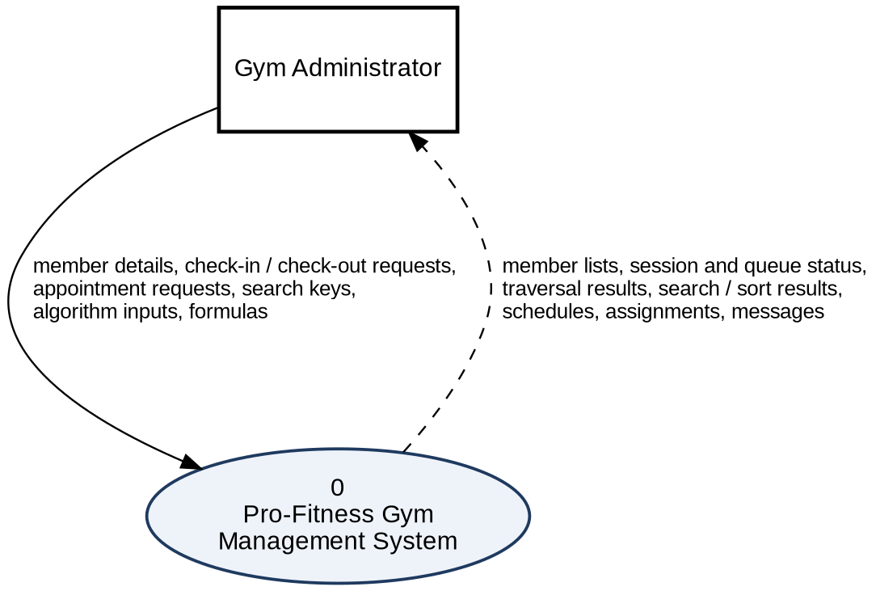
Figure 2: Level 0 data flow diagram of the Pro-Fitness Gym Management System

6.5.2 Level 1 – Processes and Data Stores
The system has nine processes and six data stores. The processes are shown in three parts for readability.
Table 7: Level 1 processes
Process | Name | Input | Output | Data stores
1.0 | Manage Members | Member data, member ID | Status message, member list | D1
2.0 | Track Check-ins | Member ID, check-out request | Stack view, message | D1 (read), D2
3.0 | Manage Appointments | Member ID, trainer, time | Queue view, message | D1 (read), D3
4.0 | Show Workout Plan Tree | Traversal type | Traversal result and steps | D4
5.0 | Look up Member (BST) | Target ID | Search path, comparisons | D1
6.0 | Navigate Zones | BFS or DFS, start zone | Visit order and steps | D5
7.0 | Search and Sort Members | Target ID, sort type | Results, counters, time | D1
8.0 | Run Algorithm Lab | Sessions, exercises, requests | Schedule, plan, assignment | D6
9.0 | Validate Formula | Formula | Valid or error message with steps | none

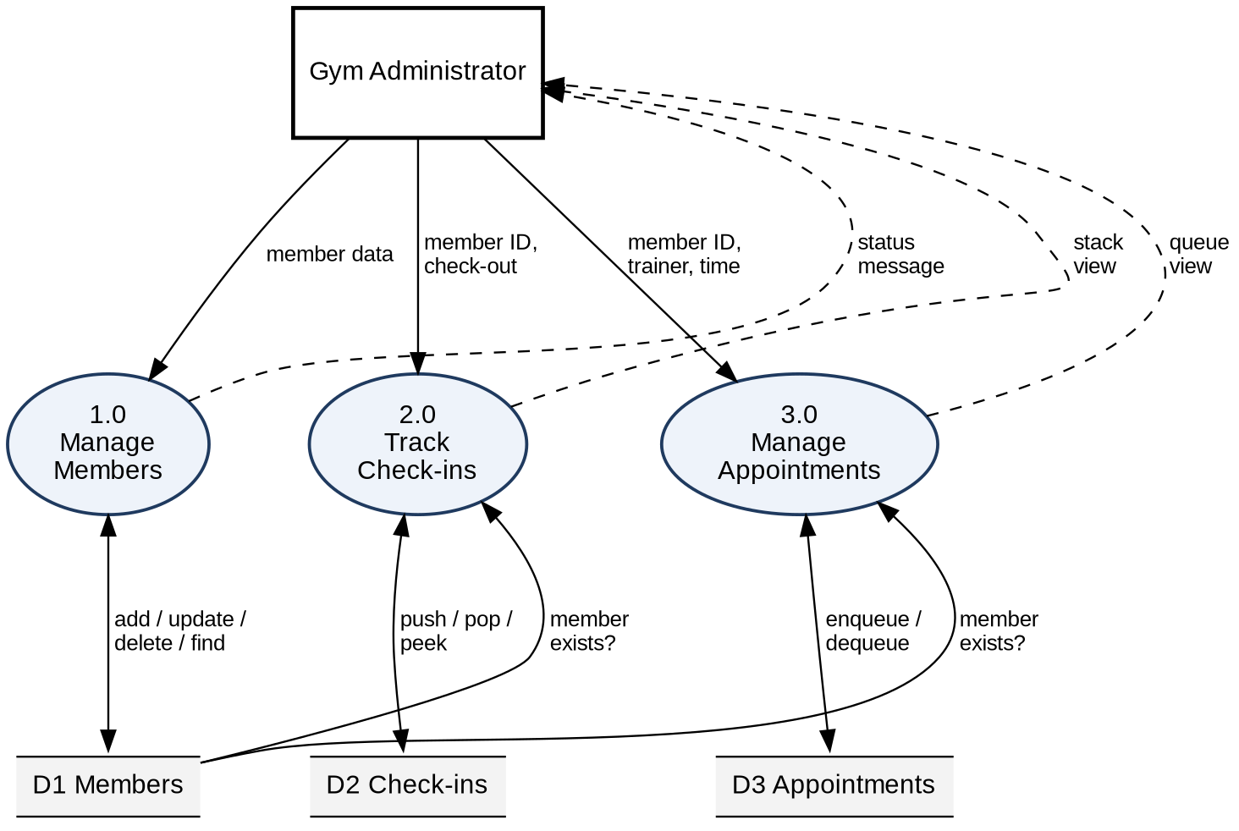
Figure 3: Level 1 DFD, part A: member, check-in and appointment processes
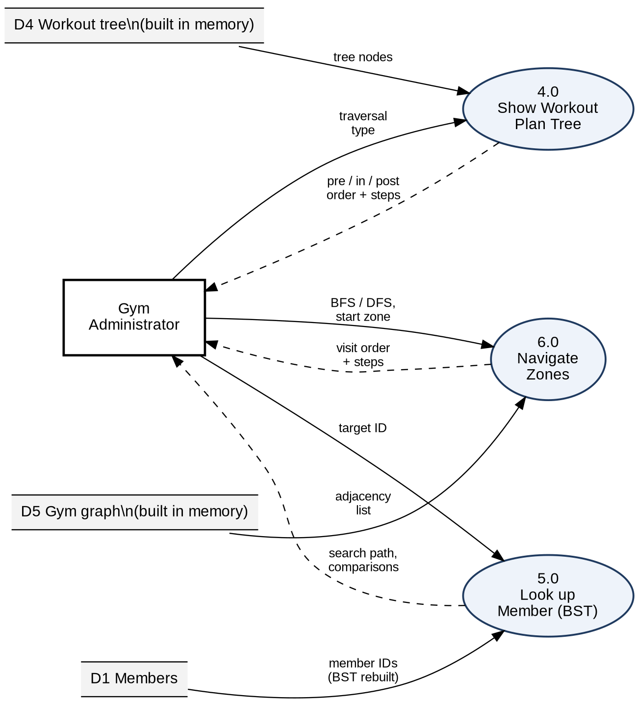
Figure 4: Level 1 DFD, part B: workout tree, BST and zone processes
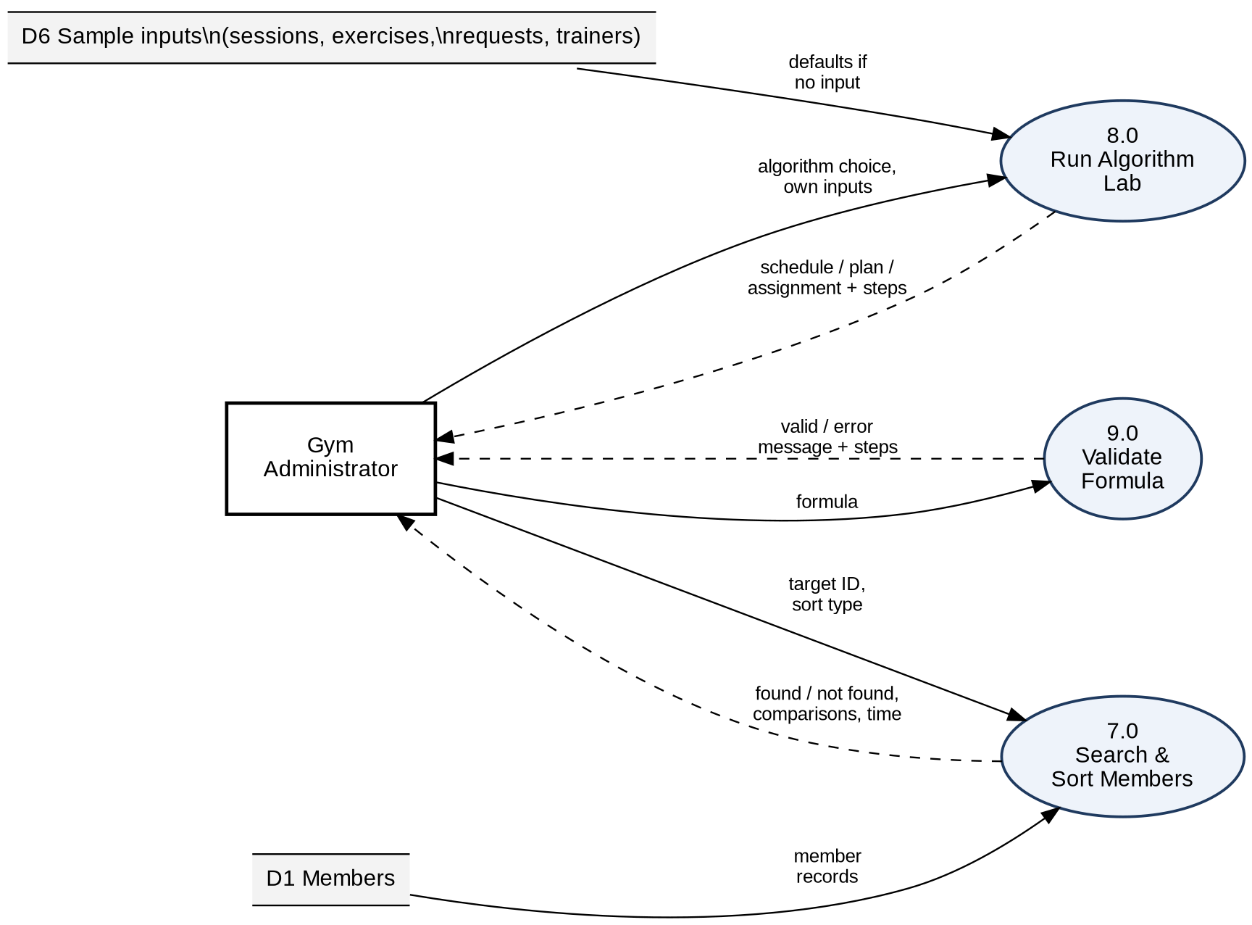
Figure 5: Level 1 DFD, part C: search and sort, algorithm lab and validation processes

6.5.3 Data Stores and Data Dictionary
Table 8: Data stores
Store | Content | Implementation
D1 Members | Member records | members.csv and the member linked list; the BST is built from it
D2 Check-ins | Members currently inside | checkins.csv and the check-in stack
D3 Appointments | Pending trainer requests | appointments.csv and the appointment queue
D4 Workout tree | Workout categories | Built in memory by buildDefaultTree()
D5 Gym graph | Zones and connections | Built in memory by buildDefaultGymLayout()
D6 Sample inputs | Default sessions, exercises, requests and trainers | Built into AlgorithmServlet; used when no input is entered

Table 9: Data dictionary
Data item | Description
memberID | Unique integer key of a member
name, membershipType, feeStatus | Text details of a member
checkInTime | Time of check-in in the format dd-MM-yyyy HH:mm
requestedTrainer, requestedTime | Trainer name and time slot of an appointment
action | Request parameter that tells a servlet which operation to run
traversalType, startZone | Tree traversal type; zone from which BFS or DFS starts
targetID | Member ID to search for
numTrainers, timeLimit | Number of trainers (1 to 5) for greedy scheduling; time budget in minutes for the knapsack
steps | List of text lines describing the algorithm's working

7. MODULES OF THE PROJECT
The modules are explained phase by phase, following the four mandatory phases of the course. Each module is described by its design (structure and operations) and its execution (how it works in the web application). Screenshot spaces are provided for the pages of the running application.
Table 10: Modules of the project by phase
Phase | Module | Data structure / algorithm | Servlet (URL) | Page
1 | Member Management | Singly Linked List | MemberServlet (/members) | members.jsp
1 | Session Tracking | Stack (LIFO) | CheckInServlet (/checkin) | checkin.jsp
1 | Trainer Appointments | Queue (FIFO) | AppointmentServlet (/appointments) | appointments.jsp
1 | Expression Validator | Stack application | ExpressionValidator class | expression.jsp
2 | Workout Plans | Binary Tree, 3 traversals | WorkoutTreeServlet (/workout-plans) | workout-plans.jsp
2 | BST Member Lookup | Binary Search Tree | BSTServlet (/bst) | bst.jsp
2 | Zone Navigation | Graph, BFS, DFS | GraphServlet (/zones) | zones.jsp
3 | Search and Sort Lab | Linear/Binary Search, Insertion/Merge Sort | SearchSortServlet (/search-sort) | search-sort.jsp
4 | Algorithm Lab | Greedy, Dynamic Programming, Backtracking | AlgorithmServlet (/algorithms) | algorithms.jsp
- | Home page, Data Management | DataStore singleton, CSV files | AppInitListener | index.jsp

7.1 Phase 1 – Linear Data Structures Implementation
Table 11: Phase 1 requirements and implementation
Phase requirement | Implementation | Class / page
Define the project | Gym Management System | whole application
Linked list for data storage | Member records in a singly linked list | MemberLinkedList, members.jsp
CRUD (insert, delete) | add, find, update and delete on members | MemberServlet
Stack using a linked list | Check-in stack of linked nodes | CheckInStack, checkin.jsp
Apply the stack to a simple problem | Bracket validation of formulas | ExpressionValidator
Additional | Queue using a linked list for appointments | AppointmentQueue

Member Management (Singly Linked List)
Purpose
The member module stores all registered members. A member list changes often, because people join, change their plan, pay fees and leave. A linked list is chosen because new members can be added and old members removed by changing references only, without shifting the other records.
Data Structure Design
Each member is stored in a MemberNode. A node holds four data fields and one reference to the next node. The MemberLinkedList keeps a reference to the first node (head) and a counter of members (size).
Table 12: Fields of MemberNode
Field | Type | Meaning
memberID | int | Unique member number (the key of the record)
name | String | Full name of the member
membershipType | String | Membership plan or tier of the member
feeStatus | String | Payment status of the member (for example Paid or Pending)
next | MemberNode | Reference to the next member node; null for the last node

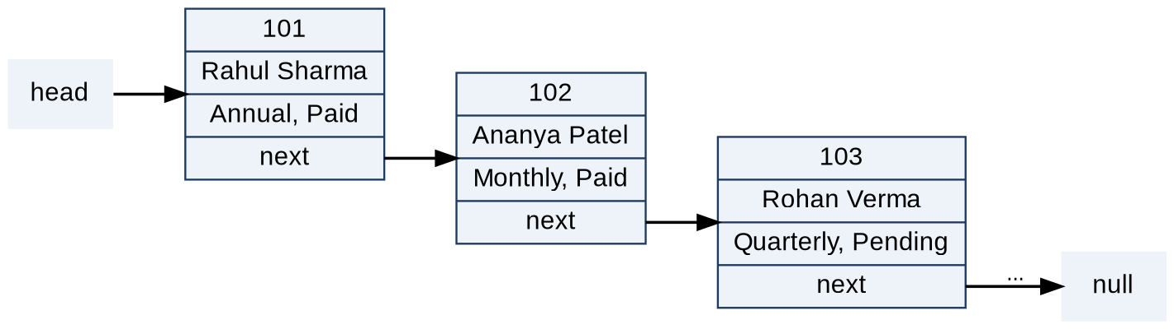
Figure 6: Members stored in a singly linked list (sample records)
Operations
Table 13: Operations of MemberLinkedList
Operation | Method | Working | Time
Insert | addMember | Rejects the call if the ID already exists; otherwise creates a node and attaches it at the end of the list. | O(n)
Find | findMemberById | Walks from head, comparing the ID in each node. | O(n)
Update | updateMember | Finds the node and replaces name, membership type and fee status. | O(n)
Delete | removeMemberById | Moves head if the first node matches; otherwise finds the previous node and links it to the node after the deleted one. | O(n)
Display | getAllMembersAsList | Traverses the list and collects the nodes for the page. | O(n)
Export / rebuild | toArray, rebuildFromArray | Copies the nodes to an array (used by sorting and searching) and links an array back into a list. | O(n)

Insertion takes O(n) time because the method first checks for a duplicate ID and then walks to the tail of the list. Deletion changes one reference and decrements the counter; no other node is moved.
Key Code
public boolean addMember(int memberID, String name, String membershipType, String feeStatus) {
if (findMemberById(memberID) != null) {
return false;
}
MemberNode newNode = new MemberNode(memberID, name, membershipType, feeStatus);
if (head == null) {
head = newNode;
} else {
MemberNode current = head;
while (current.next != null) {
current = current.next;
}
current.next = newNode;
}
size++;
return true;
}
Insertion into the member linked list (MemberLinkedList.java)
public boolean removeMemberById(int memberID) {
if (head == null) {
return false;
}
if (head.memberID == memberID) {
head = head.next;
size--;
return true;
}
MemberNode current = head;
while (current.next != null && current.next.memberID != memberID) {
current = current.next;
}
if (current.next == null) {
return false; // Member with ID not found
}
current.next = current.next.next;
size--;
return true;
}
Deletion from the member linked list (MemberLinkedList.java)
Web Interface
The page members.jsp is served by MemberServlet at the address /members. A GET request shows the member table, with the columns Node ID, Member Name, Membership Tier, Fee Status, Memory Link and Operations, and the total number of members. The page has four forms, and each form sends a POST request with an action value:
- add: registers a member. Member ID and name are compulsory. If the membership type is empty it is stored as "Standard", and if the fee status is empty it is stored as "Pending". After a successful insert the member is also inserted into the member BST and members.csv is saved.
- find: looks up a member by ID with a linear traversal and shows the found record above the table.
- update: changes the name, membership type and fee status of an existing member, refreshes the BST entry and saves the file.
- delete: removes the member from the linked list and from the BST and saves the file.
Invalid input, such as a missing ID, a non-numeric ID, a duplicate ID or an unknown ID, produces an error message instead of a change in the data.

Figure 7: Member table showing the linked list records

Figure 8: Registering a new member (add form and success message)

Figure 9: Updating and deleting a member, with the confirmation message
Session Tracking (Stack)
Purpose
The session tracking module records the members who are currently inside the gym. Members are checked in as they arrive. A stack gives Last In, First Out behaviour: the member who checked in most recently is the first to be removed on a check-out and is always visible at the top.
Data Structure Design
The stack is built from linked nodes. A CheckInNode stores the member ID, the member name and the check-in time, with a reference to the node below it. The CheckInStack keeps only a reference to the top node and the size. A push places a new node above the old top, and a pop removes the top node.
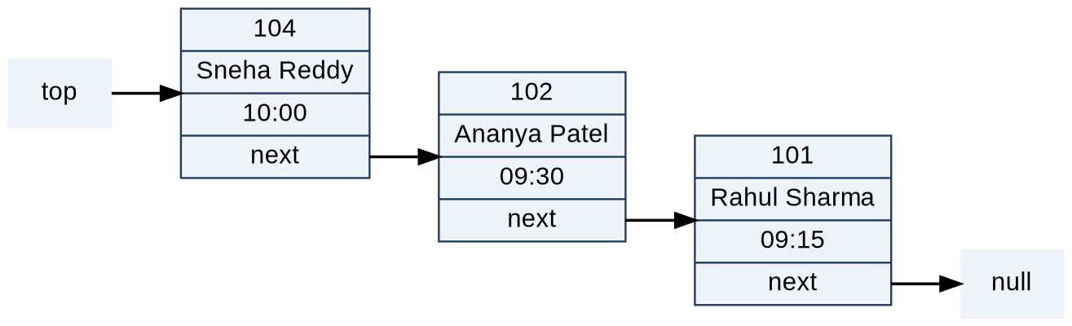
Figure 10: Check-in stack with the most recent arrival at the top (sample records)
Table 14: Operations of CheckInStack
Operation | Method | Working | Time
Push | push | Creates a node, points its next reference to the current top and makes it the new top. | O(1)
Pop | pop | Returns the top node, moves top to the next node and reduces the size; returns null if the stack is empty. | O(1)
Peek | peek | Returns the top node without removing it. | O(1)
Is empty / size | isEmpty, getSize | Checks the top reference or returns the counter. | O(1)
Duplicate check | isMemberCheckedIn | Walks from top to bottom looking for the member ID. | O(n)
List | getAllCheckedInAsList | Collects nodes from top to bottom for display. | O(n)

public void push(int memberID, String memberName, String checkInTime) {
CheckInNode newNode = new CheckInNode(memberID, memberName, checkInTime);
newNode.next = top;
top = newNode;
size++;
}

public CheckInNode pop() {
if (top == null) {
return null;
}
CheckInNode checkedOutMember = top;
top = top.next;
checkedOutMember.next = null;
size--;
return checkedOutMember;
}
Push and pop of the check-in stack (CheckInStack.java)
Web Interface
The page checkin.jsp is served by CheckInServlet at /checkin. It shows the number of members checked in, the latest check-in (the stack top), the list of registered members to choose from, and the stack contents from the top downwards. Two actions are available:
- checkin: the member ID must belong to a registered member and the member must not be already inside. The check-in time is taken from the system clock in the format dd-MM-yyyy HH:mm, the member is pushed, and checkins.csv is saved.
- checkout: pops the top of the stack, that is, the most recent check-in, and shows the name of the member who was checked out. If the stack is empty an error message is shown.
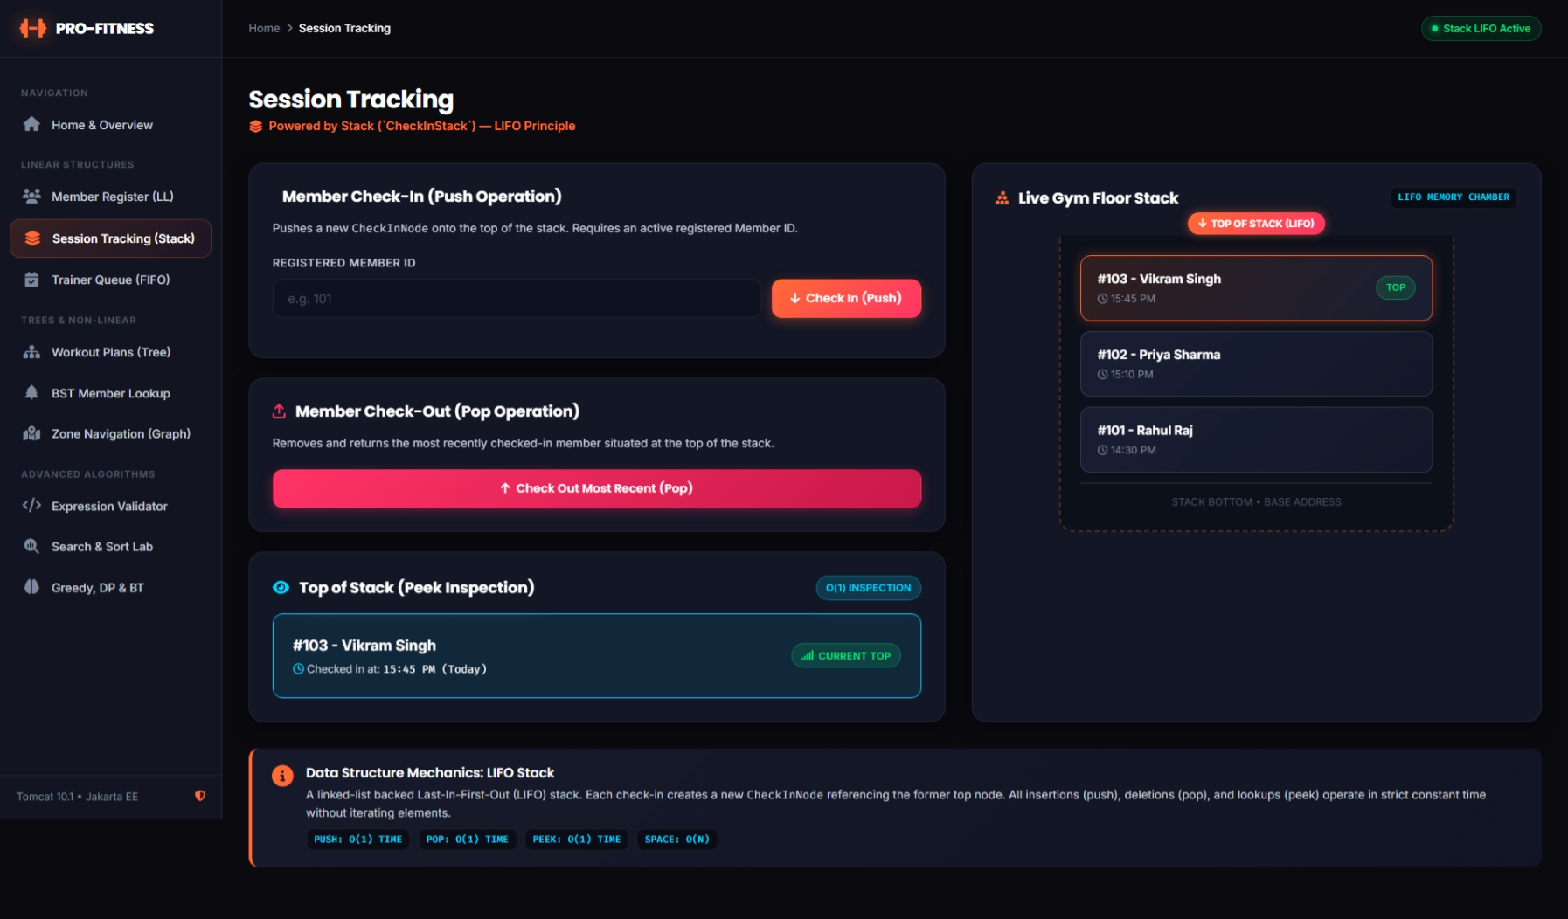
Figure 11: Session tracking page: current stack and latest check-in
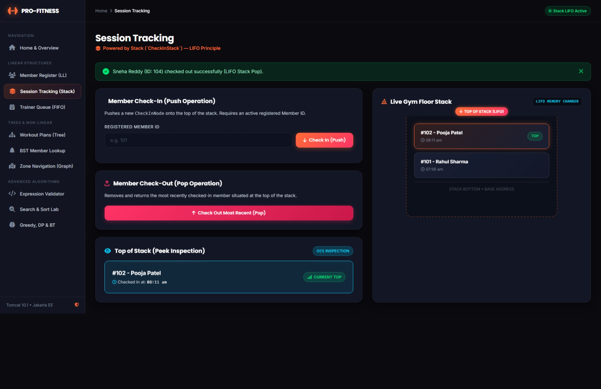
Figure 12: Check-out of the most recent member (pop)
Trainer Appointments (Queue)
Purpose
Members request personal-training sessions with a trainer. These requests must be served fairly, in the order in which they arrive. A queue gives First In, First Out behaviour: a new request is added at the rear and the oldest request is taken from the front.
Data Structure Design
The queue is built from linked nodes. An AppointmentNode stores the member ID, the member name, the requested trainer and the requested time. The AppointmentQueue keeps two references, front and rear, and the size. Keeping a rear reference makes both ends fast.
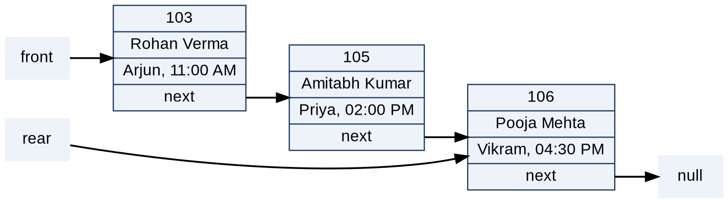
Figure 13: Appointment queue with front and rear references (sample records)
Table 15: Operations of AppointmentQueue
Operation | Method | Working | Time
Enqueue | enqueue | Creates a node and attaches it after rear; if the queue was empty, front and rear both point to the new node. | O(1)
Dequeue | dequeue | Returns the front node and moves front forward; if the queue becomes empty, rear is set to null. | O(1)
Peek | peek | Returns the front node without removing it. | O(1)
List | getAllAppointmentsAsList | Collects the nodes from front to rear. | O(n)

public void enqueue(int memberID, String memberName, String requestedTrainer, String requestedTime) {
AppointmentNode newNode = new AppointmentNode(memberID, memberName, requestedTrainer, requestedTime);
if (rear == null) {
front = newNode;
rear = newNode;
} else {
rear.next = newNode;
rear = newNode;
}
size++;
}

public AppointmentNode dequeue() {
if (front == null) {
return null;
}
AppointmentNode processedAppointment = front;
front = front.next;
processedAppointment.next = null;
size--;
if (front == null) {
rear = null;
}
return processedAppointment;
}
Enqueue and dequeue of the appointment queue (AppointmentQueue.java)
Web Interface
The page appointments.jsp is served by AppointmentServlet at /appointments. It shows the number of pending requests, the next request in line (the front of the queue) and the queue contents. The request form has the member ID, a list of certified trainers (Arjun for strength and conditioning, Priya for cardio and endurance, Vikram for functional crossfit, Neha for HIIT and weight loss, and Karthik for flexibility and rehabilitation) and a time slot. Two actions are available:
- request: the member ID must belong to a registered member and a trainer must be selected. The request is enqueued at the rear and appointments.csv is saved. If no time is given, "10:00 AM" is used.
- process: dequeues the oldest request, shows which member was served, and saves the file. If the queue is empty an error message is shown.
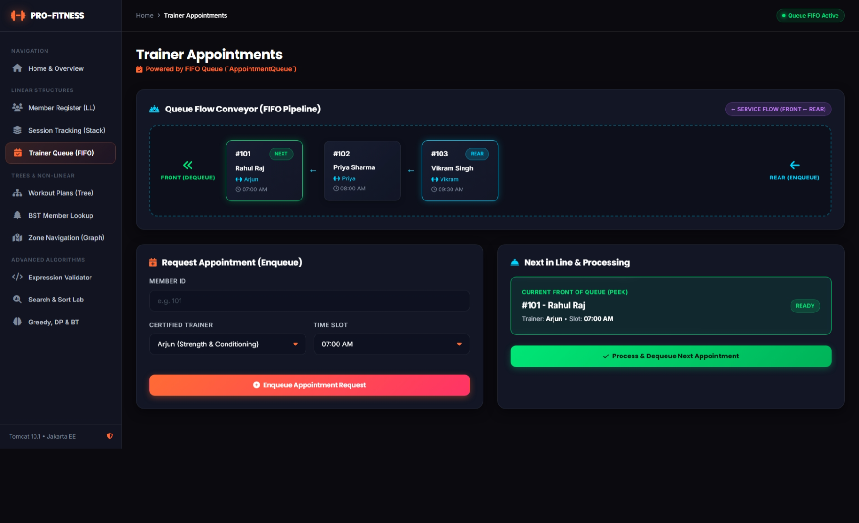
Figure 14: Appointment queue page: front request and pending list
Expression Validator (Stack Application)
Purpose
This module is the simple application of a stack required in the first phase. A workout-plan formula, for example {Sets * (Reps + Weight)}, is valid only if every opening bracket is closed by the matching closing bracket in the correct order. The check is done with a stack, because the most recently opened bracket must be the first to be closed.
Algorithm
The class ExpressionValidator contains its own private stack (CharStack), built from CharStackNode objects that store the bracket and its position in the formula. The formula is read from left to right:
- When an opening bracket (, [ or { is found, it is pushed on the stack together with its position.
- When a closing bracket ), ] or } is found and the stack is empty, the formula is invalid because there is a closing bracket with no opening bracket.
- Otherwise the top of the stack is popped. If it is not the matching opening bracket, the formula is invalid because of a mismatch.
- After the last character, if the stack is not empty the formula is invalid because an opening bracket was never closed. If it is empty the formula is valid.
The validator returns a ValidationResult with the result, a message that gives the position of the error, and the list of steps showing the stack after each push and pop. The time is O(n) for a formula of n characters.
Table 16: Results of the bracket validator for sample formulas
Formula | Result | Message
{Sets * (Reps + Weight)} | Valid | Expression has valid and balanced brackets.
{Sets * (Reps + Weight} | Invalid | Mismatched bracket at index 22: expected the closing counterpart for '(' (from index 8), but found '}'.
(Sets + Reps)) | Invalid | Unmatched closing bracket ')' found at index 13 with no preceding opening bracket.
[Cardio + (HIIT * 2] | Invalid | Mismatched bracket at index 19: expected the closing counterpart for '(' (from index 10), but found ']'.

The page expression.jsp provides the input field for the formula, and the DataStore holds a validator instance that the application can use for the check.
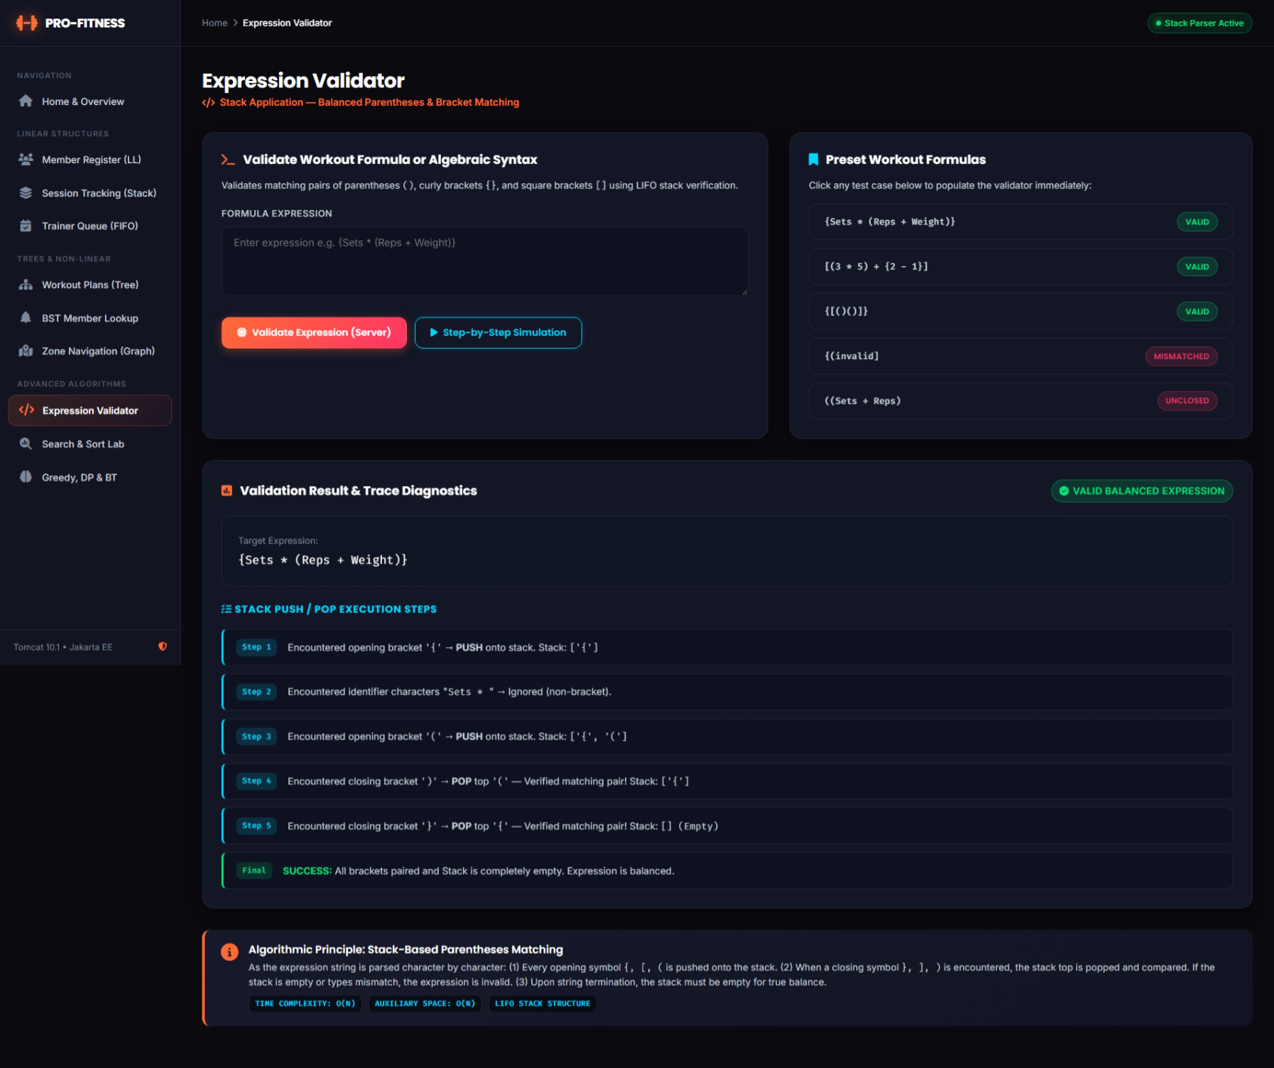
Figure 16: Expression Validator page with an invalid formula and the stack steps
Worked examples for Phase 1
Check-in stack. With the default data the stack holds members 101, 102 and 104, with 104 at the top. A check-in of member 105 pushes it on top; the next check-out pops 105 and the one after that pops 104. Member 101, who arrived first, leaves last.
Bracket validation of the formula {Sets * (Reps + Weight)}:
Step | Index | Character | Action | Stack after
1 | 0 | { | push | {
2 | 8 | ( | push | { (
3 | 22 | ) | pop ( (match) | {
4 | 23 | } | pop { (match) | empty

The stack is empty at the end, so the formula is valid.

7.2 Phase 2 – Hierarchical and Graph Structures
Table 17: Phase 2 requirements and implementation
Phase requirement | Implementation | Class / page
Binary tree for structured data | Workout plan categories | WorkoutBinaryTree
Three traversals | Pre-order, in-order, post-order | workout-plans.jsp
BST for efficient data access | Members by ID | MemberBST, bst.jsp
Basic graph representation | Zones as an adjacency list | GymGraph
Simple traversal | BFS and DFS | zones.jsp

Workout Plans (Binary Tree)
Purpose
Workout plans have a natural hierarchy: the plans are divided into types, and a type is divided into body parts or training styles. A binary tree represents this hierarchy, with every category as a node that can have at most two children. The module displays the tree and shows its three traversals.
Data Structure Design
A WorkoutTreeNode stores the category name and references to the left and right child. The WorkoutBinaryTree keeps the root and builds the default hierarchy in buildDefaultTree(). The tree of the application is shown in the figure below.
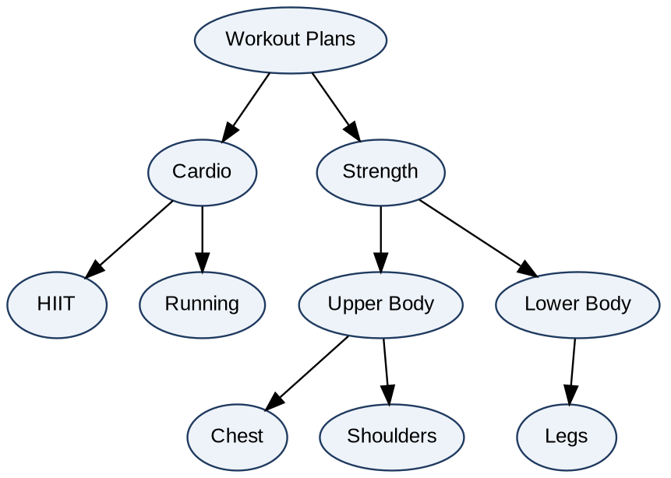
Figure 17: Binary tree of workout plan categories
Traversals
The three traversals differ in the moment at which the current node is visited. Each is implemented as a recursive method, and a companion method records the steps (visit, go left, return, go right) for display.
Table 18: Traversals of the workout plan tree
Traversal | Order | Result for the workout tree
Pre-order | Root, Left, Right | Workout Plans, Cardio, HIIT, Running, Strength, Upper Body, Chest, Shoulders, Lower Body, Legs
In-order | Left, Root, Right | HIIT, Cardio, Running, Workout Plans, Chest, Upper Body, Shoulders, Strength, Lower Body, Legs
Post-order | Left, Right, Root | HIIT, Running, Cardio, Chest, Shoulders, Upper Body, Legs, Lower Body, Strength, Workout Plans

private void preorderRecursive(WorkoutTreeNode node, ArrayList<String> result) {
if (node == null) return;
result.add(node.category);
preorderRecursive(node.left, result);
preorderRecursive(node.right, result);
}

private void inorderRecursive(WorkoutTreeNode node, ArrayList<String> result) {
if (node == null) return;
inorderRecursive(node.left, result);
result.add(node.category);
inorderRecursive(node.right, result);
}

private void postorderRecursive(WorkoutTreeNode node, ArrayList<String> result) {
if (node == null) return;
postorderRecursive(node.left, result);
postorderRecursive(node.right, result);
result.add(node.category);
}
The three recursive traversals (WorkoutBinaryTree.java)
Each traversal visits every node exactly once, so its time is O(n). The depth of the recursion equals the height of the tree.
Web Interface
The page workout-plans.jsp is served by WorkoutTreeServlet at /workout-plans. When the page opens it shows the tree and the pre-order, in-order and post-order lists. The user can choose a traversal type and send the traverse action; the page then shows the selected result and the numbered steps of that traversal.
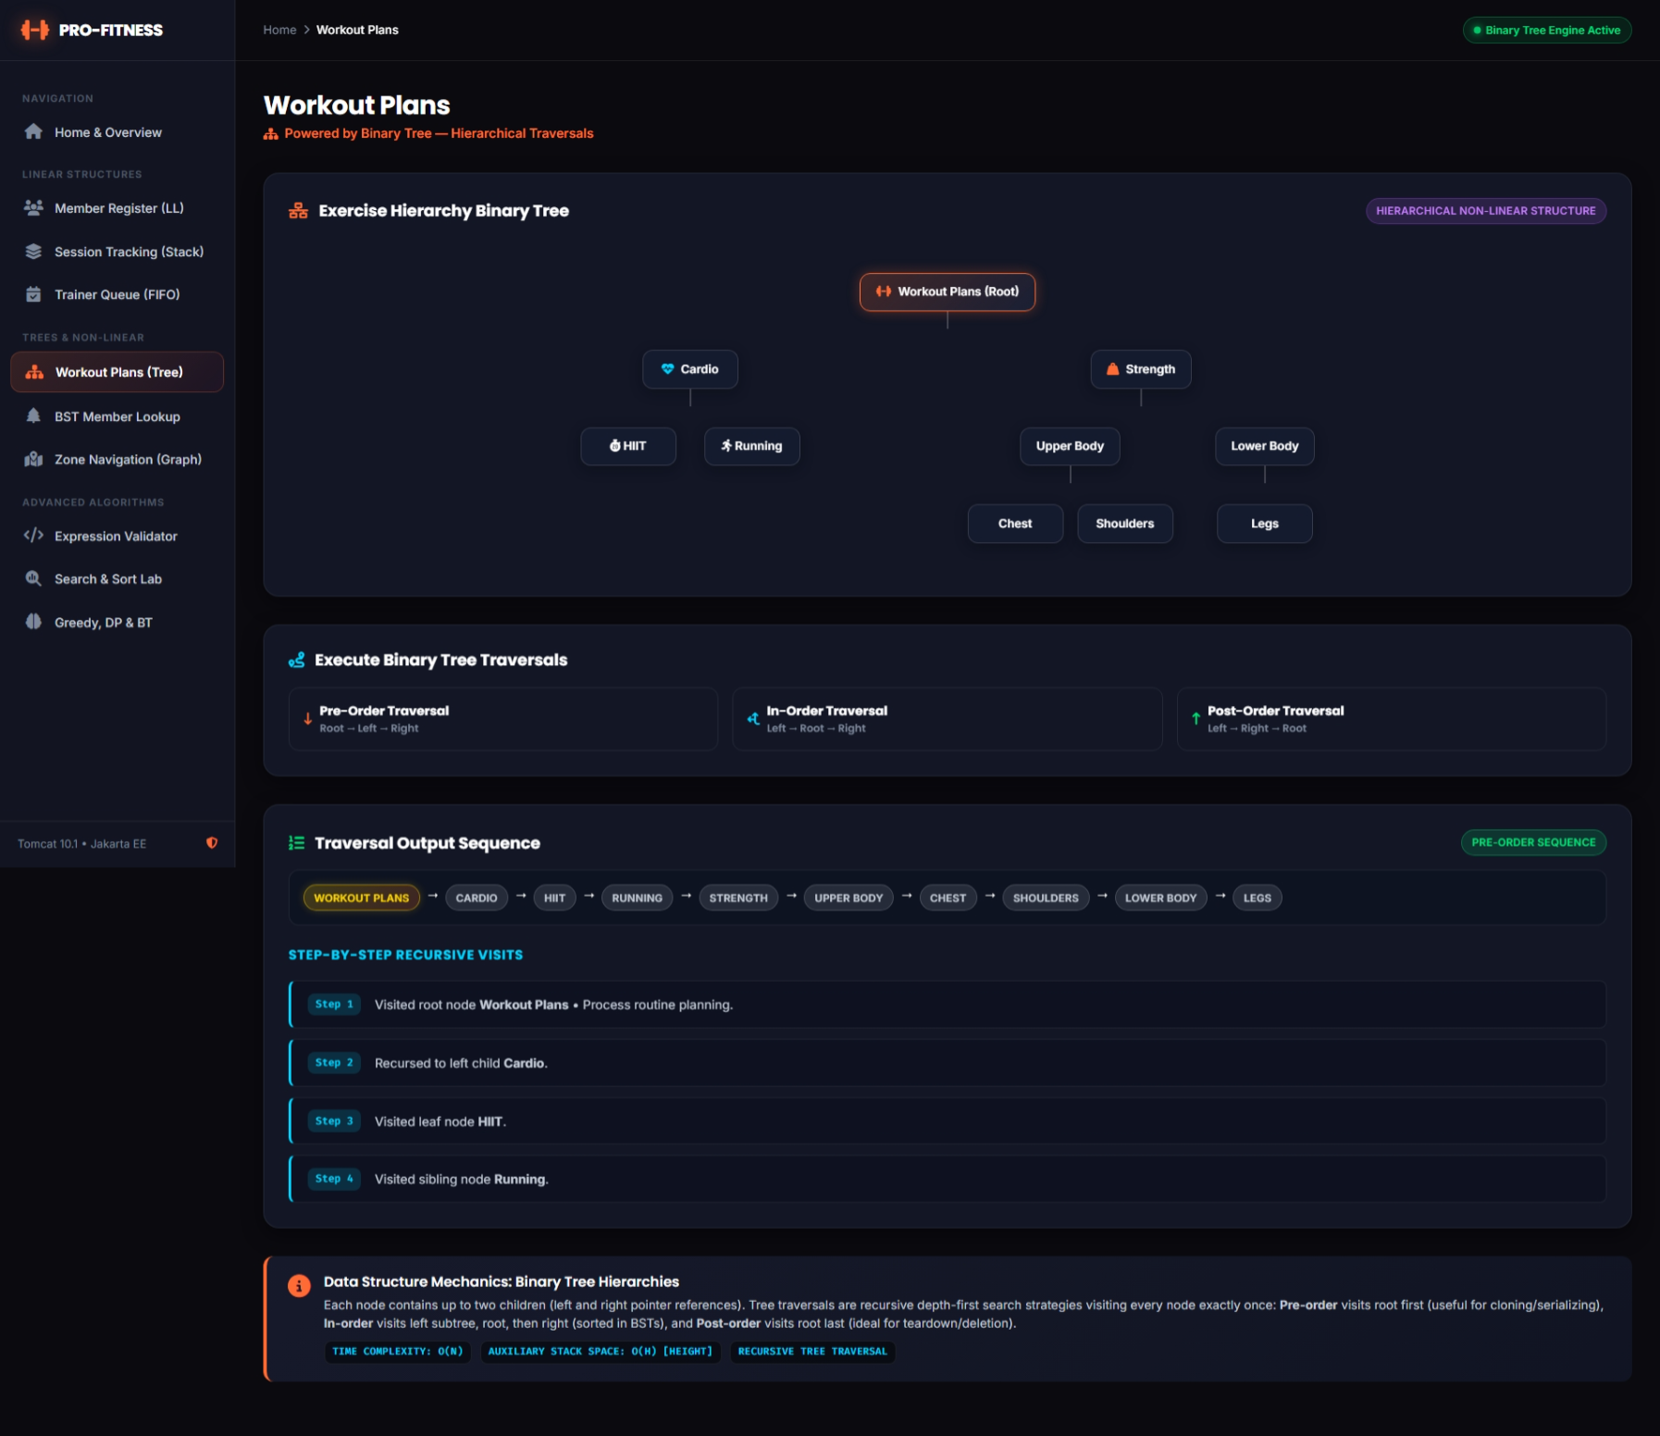
Figure 18: Workout plan binary tree displayed on the page
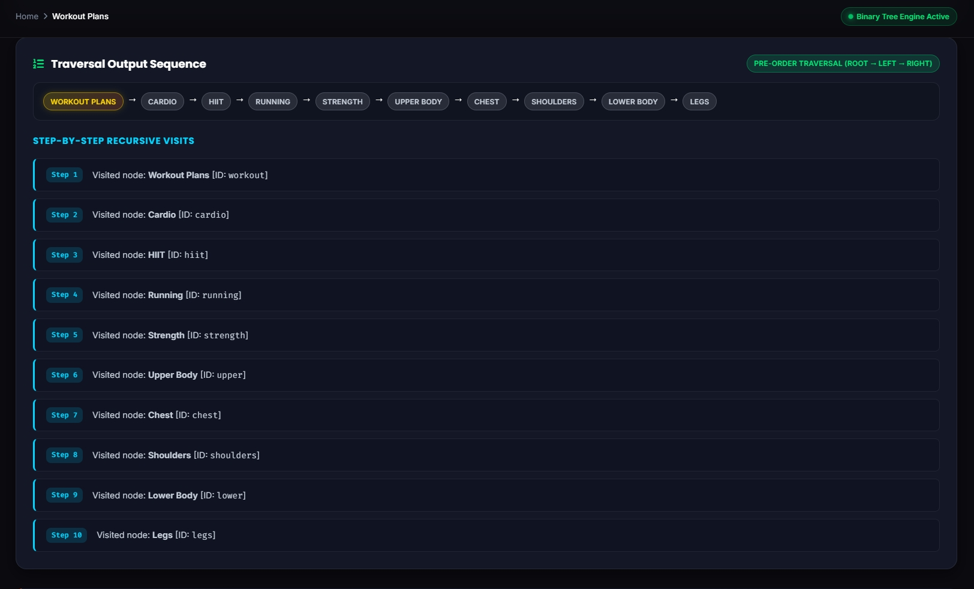
Figure 19: Step-by-step trace of a selected traversal
BST Member Lookup (Binary Search Tree)
Purpose
A binary search tree keeps the member IDs in an order that makes searching fast. At every node, the IDs in the left subtree are smaller and the IDs in the right subtree are larger. A search therefore compares the target with the current node and moves either left or right, discarding a whole branch at every step.
Data Structure Design
A BSTNode stores the member ID, the member name and the left and right child. MemberBST keeps the root and the size. The tree is kept in step with the linked list: the member servlet inserts into the BST after a member is added, updates it after an update, and deletes from it after a delete. The tree can also be rebuilt completely from the linked list with buildFromMemberList.
Table 19: Operations of MemberBST (h is the height of the tree)
Operation | Method | Working | Time
Insert | insert | Recursively goes left or right by comparing IDs; a new leaf is created at the empty place. An existing ID only updates the stored name. | O(h)
Search | search | Iterative; compares the key with each node, records the path and counts comparisons. | O(h)
Delete | delete | Handles a leaf, a node with one child, and a node with two children (replaced by the smallest node of the right subtree, the in-order successor). | O(h)
In-order listing | inorderTraversal | Left, node, right; gives the IDs in ascending order. | O(n)
Rebuild | buildFromMemberList | Clears the tree and inserts every member of the linked list in list order. | O(n x h)

private BSTNode insertRecursive(BSTNode current, int memberID, String memberName) {
if (current == null) {
size++;
return new BSTNode(memberID, memberName);
}
if (memberID < current.memberID) {
current.left = insertRecursive(current.left, memberID, memberName);
} else if (memberID > current.memberID) {
current.right = insertRecursive(current.right, memberID, memberName);
} else {
current.memberName = memberName;
}
return current;
}
Recursive insertion into the member BST (MemberBST.java)
BSTNode current = root;
while (current != null) {
comparisons++;
if (memberID == current.memberID) {
// found: record the step and return the result
} else if (memberID < current.memberID) {
current = current.left;
} else {
current = current.right;
}
}
Core loop of the BST search (MemberBST.java, step messages omitted)
Effect of the Shape of the Tree
The cost of a search depends on the height of the tree. When the IDs arrive in a mixed order the tree is bushy and a search needs about log2(n) comparisons. The BST of the application is rebuilt from the linked list in list order, so if the member IDs were registered in ascending order (101, 102, 103, ...) every new node becomes the right child of the previous one and the tree degenerates into a chain, as shown in the second figure below. A search then needs up to n comparisons, like a linear search. The first figure below shows members inserted in a mixed order, which gives a shorter tree.
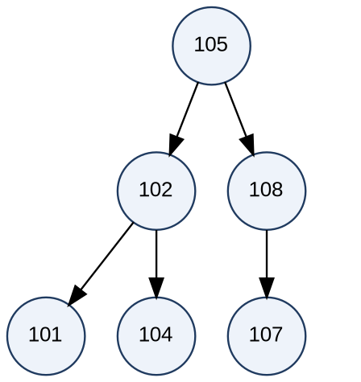
Figure 20: BST built from the IDs 105, 102, 108, 101, 104, 107 (height 3)
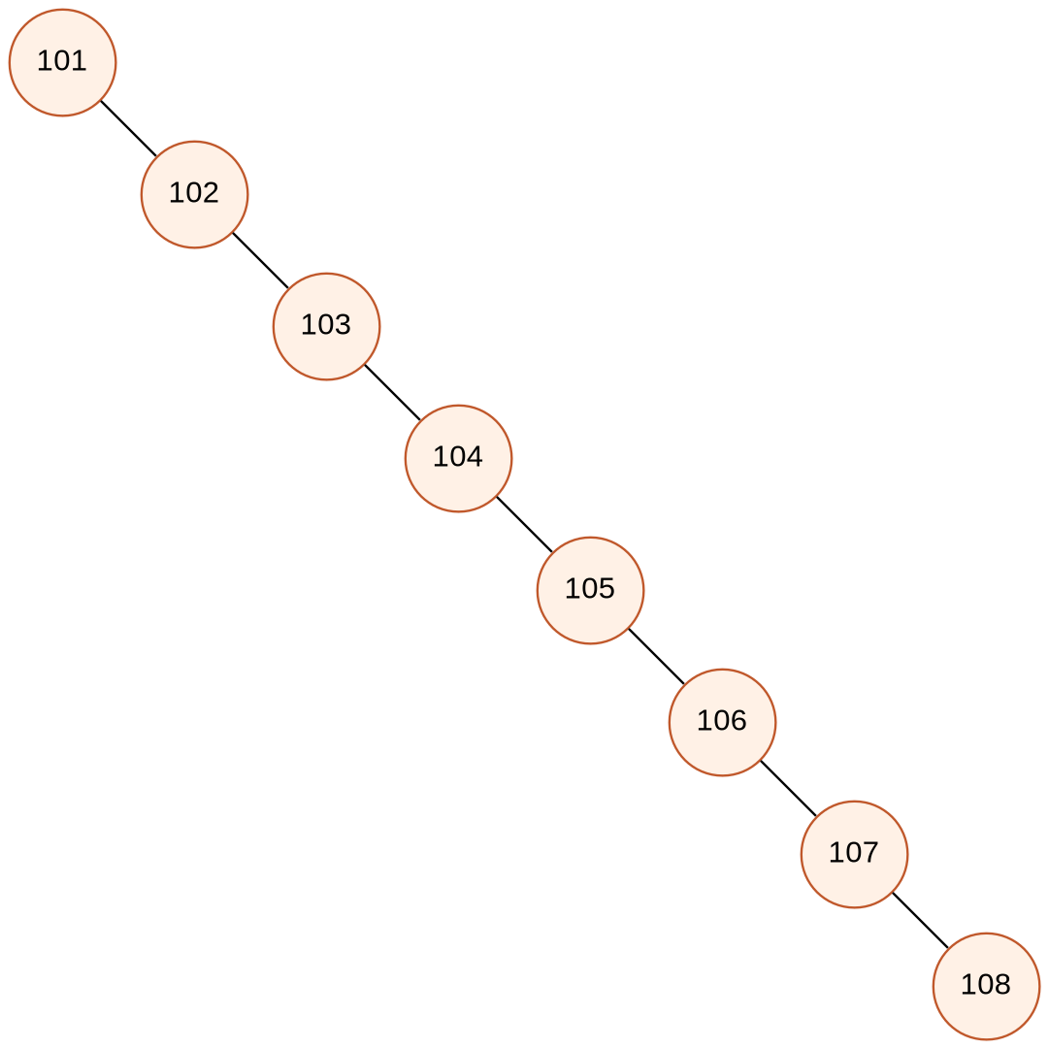
Figure 21: BST built from the IDs 101 to 108 inserted in ascending order (right-skewed chain)
With the eight default members, a search for ID 108 in the skewed tree takes 8 comparisons, while the same search in the sorted array with binary search takes 4. This comparison is useful for understanding why balanced trees such as AVL trees are used in practice (see Section 10).
Web Interface
The page bst.jsp is served by BSTServlet at /bst. It shows the number of nodes and a table of the BST in in-order sequence with the columns BST Key (ID), Member Name, Membership Tier, Fee Status and Tree Position. The search action takes a target ID and shows whether it was found, the path followed through the tree with the comparison made at every node, and the total number of comparisons. The rebuild action rebuilds the tree from the current member list.

Zone Navigation (Graph)
Purpose
A gym floor is divided into zones, and some zones are directly connected by a path. This is a graph: the zones are vertices and the paths are edges. The module represents the gym layout as a graph and traverses it from any starting zone to show which zones can be reached and in what order.
Data Structure Design
The graph is undirected and is stored as an adjacency list. GymGraph keeps a map from the name of each zone to the list of its neighbouring zones. The method addConnection adds each zone to the neighbour list of the other, so a path can be walked in both directions, and it avoids duplicate entries. The default layout has six zones and seven paths.
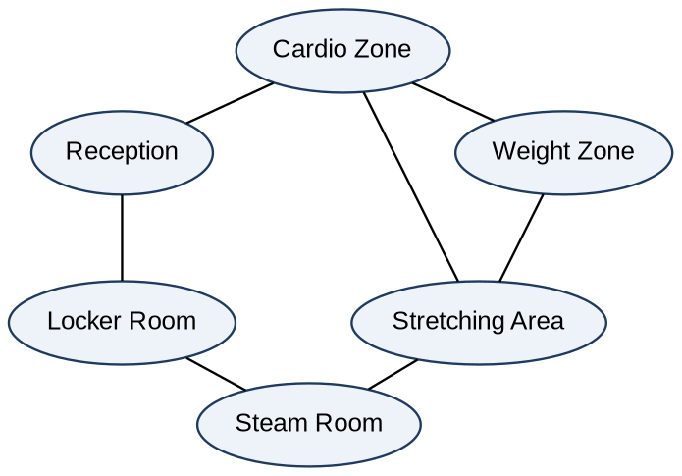
Figure 24: Gym zone graph (6 zones, 7 connections)
Table 20: Adjacency list of the gym graph
Zone (vertex) | Adjacent zones
Reception | Cardio Zone, Locker Room
Cardio Zone | Reception, Weight Zone, Stretching Area
Weight Zone | Cardio Zone, Stretching Area
Stretching Area | Cardio Zone, Weight Zone, Steam Room
Locker Room | Reception, Steam Room
Steam Room | Stretching Area, Locker Room

Traversals
Breadth-First Search (BFS) visits the zones level by level. It uses a queue and a set of visited zones: the start zone is enqueued; then, repeatedly, a zone is dequeued and visited and its unvisited neighbours are enqueued. BFS shows the zones closest to the start first.
Depth-First Search (DFS) follows one path as deep as possible and then backtracks. It is implemented recursively: a zone is visited and the method calls itself for each unvisited neighbour.
Queue<String> queue = new java.util.LinkedList<>();
Set<String> visited = new HashSet<>();
visited.add(startZone);
queue.add(startZone);
while (!queue.isEmpty()) {
String current = queue.poll();
visitOrder.add(current);
ArrayList<String> neighbors = adjacencyList.getOrDefault(current, new ArrayList<>());
for (String neighbor : neighbors) {
if (!visited.contains(neighbor)) {
visited.add(neighbor);
queue.add(neighbor);
}
}
}
Core of the BFS traversal (GymGraph.java, step messages omitted)
Table 21: Traversal results from Reception
Start zone | BFS order | DFS order
Reception | Reception, Cardio Zone, Locker Room, Weight Zone, Stretching Area, Steam Room | Reception, Cardio Zone, Weight Zone, Stretching Area, Steam Room, Locker Room

Both traversals visit each vertex once and examine each edge, so the time is O(V + E), where V is the number of zones and E is the number of paths. A zone that does not exist is rejected, and if no start zone is given, Reception is used.
Web Interface
The page zones.jsp is served by GraphServlet at /zones. It shows the adjacency list of the gym and a form with a list of source zones (Reception as vertex 0, Cardio Zone as vertex 1, and so on). The actions bfs and dfs run the selected traversal from the chosen zone and show the visit order and the numbered steps, including the queue contents after every step for BFS and the advance and backtrack moves for DFS.
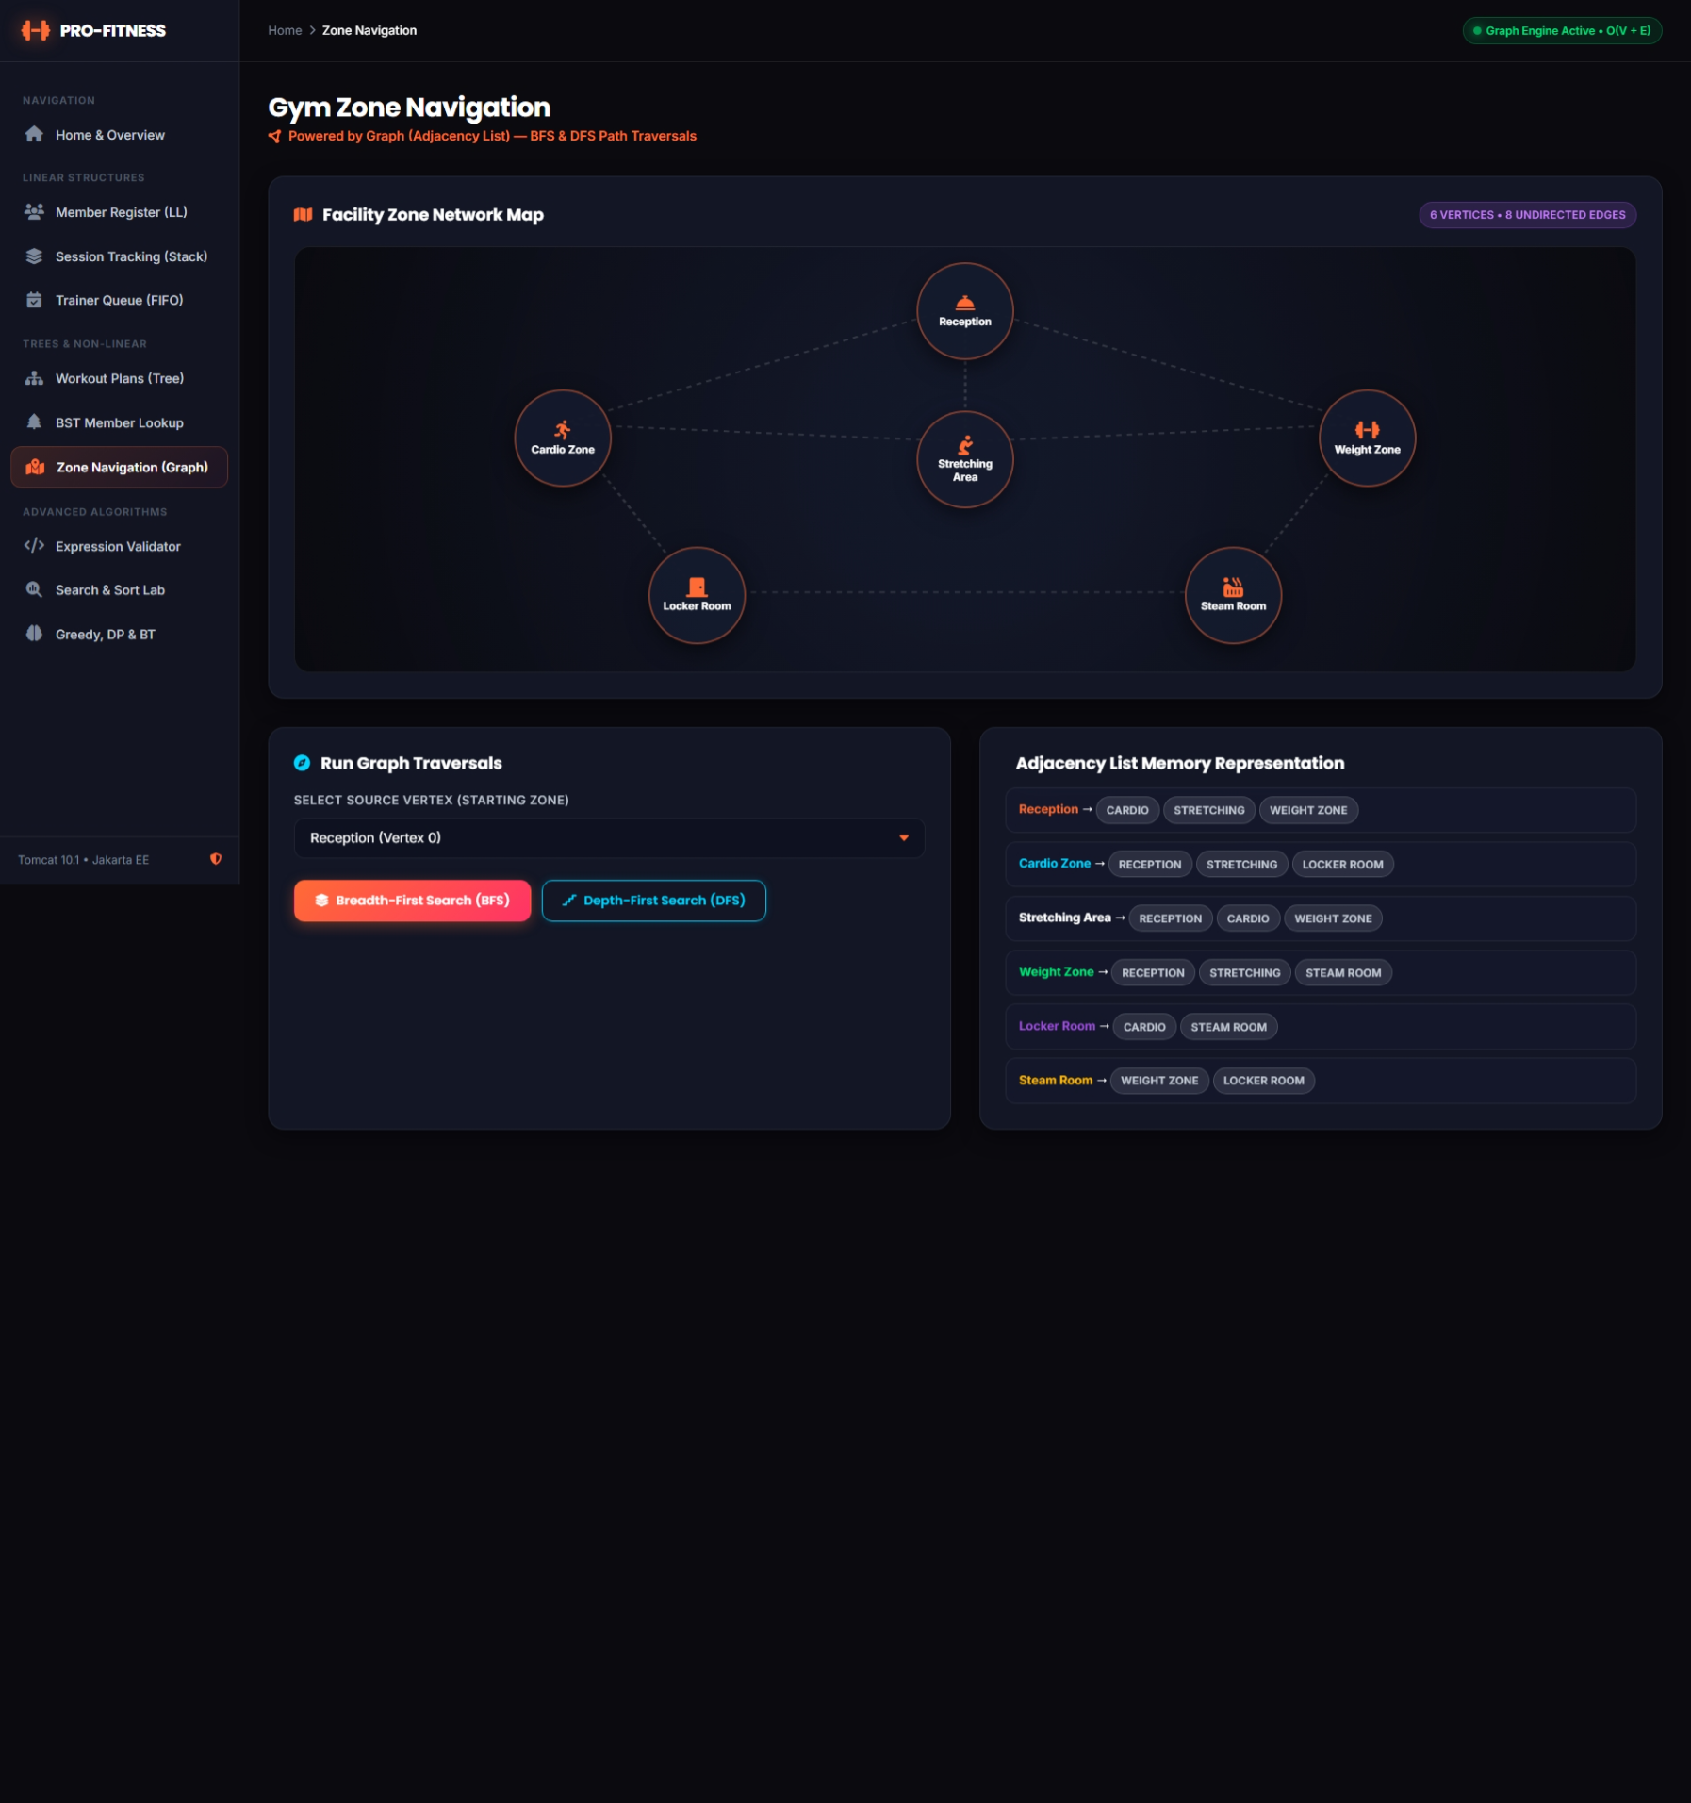
Figure 25: Zone navigation page: adjacency list of the gym graph
Worked examples for Phase 2
BST search. In a BST built from 105, 102, 108, 101, 104 and 107, searching for 104 compares with 105 (smaller, go left), then 102 (larger, go right), then finds 104: 3 comparisons for 6 members.
BFS from Reception.
Step | Visited | Queue after dequeue | Newly enqueued
1 | Reception | empty | Cardio Zone, Locker Room
2 | Cardio Zone | Locker Room | Weight Zone, Stretching Area
3 | Locker Room | Weight Zone, Stretching Area | Steam Room
4 | Weight Zone | Stretching Area, Steam Room | none
5 | Stretching Area | Steam Room | none
6 | Steam Room | empty | none

7.3 Phase 3 – Searching and Sorting Operations
Table 22: Phase 3 requirements and implementation
Phase requirement | Implementation | Class / page
Linear and binary search | Search by member ID | SearchAlgorithms
Merge and insertion sort | Sort members by ID | SortAlgorithms
Use within the project workflow | Sorting before binary search on the member list | SearchSortServlet
Compare performance | Comparison counts and time shown on the page | search-sort.jsp

Purpose
This module applies two search methods and two sorting methods to the real member list and compares them. The member linked list is copied into an array with toArray(), because binary search and the sorting methods work by index. The algorithms work on a copy of the references, so the order of the stored member list is not changed by sorting.
Searching
Linear search examines the members one after another from the start of the array until the ID matches or the array ends. It does not need sorted data. Binary search works on an array sorted by member ID: it compares the target with the middle element and discards the half that cannot contain the target. Each algorithm returns a SearchResult with the member (if found), the number of comparisons, the time in nanoseconds and the steps.
int low = 0;
int high = sortedMembers.length - 1;
while (low <= high) {
int mid = low + (high - low) / 2;
MemberNode midNode = sortedMembers[mid];
comparisons++;
int midID = midNode.getMemberID();
if (midID == targetID) {
// found: return the result
} else if (midID > targetID) {
high = mid - 1;
} else {
low = mid + 1;
}
}
Core of the binary search (SearchAlgorithms.java, null checks and step messages omitted)
Sorting
Insertion sort takes each element in turn and shifts the larger elements of the sorted part one place to the right until the element can be inserted in its place. It is simple and fast for small or almost sorted data. Merge sort splits the array into halves, sorts each half recursively and merges the two sorted halves. It always takes O(n log n) time but needs extra space for the merge. Both sorts order the members by member ID and count the comparisons and the shifts or merge moves.
for (int i = 1; i < arr.length; i++) {
MemberNode key = arr[i];
int j = i - 1;
while (j >= 0) {
result.incrementComparisons();
if (arr[j] != null && key != null && arr[j].getMemberID() > key.getMemberID()) {
arr[j + 1] = arr[j];
result.incrementSwapsOrMerges();
j--;
} else {
break;
}
}
arr[j + 1] = key;
}
Insertion sort loop (SortAlgorithms.java, step messages omitted)
int i = 0, j = 0, k = left;
while (i < n1 && j < n2) {
result.incrementComparisons();
int id1 = leftArr[i] != null ? leftArr[i].getMemberID() : Integer.MAX_VALUE;
int id2 = rightArr[j] != null ? rightArr[j].getMemberID() : Integer.MAX_VALUE;
if (id1 <= id2) {
arr[k] = leftArr[i];
i++;
} else {
arr[k] = rightArr[j];
j++;
}
result.incrementSwapsOrMerges();
k++;
}
while (i < n1) { arr[k] = leftArr[i]; result.incrementSwapsOrMerges(); i++; k++; }
while (j < n2) { arr[k] = rightArr[j]; result.incrementSwapsOrMerges(); j++; k++; }
Merge step of merge sort (SortAlgorithms.java, step messages omitted)
Use in the Project Workflow
Sorting and searching are used inside the member workflow, not only as separate demonstrations. When the user searches for a member in this module, SearchSortServlet first runs a linear search on the member array in list order, then sorts a copy of the array with merge sort, and then runs binary search on the sorted copy. The page shows both results side by side with the number of comparisons for each, so the saving from binary search is visible for the real data. The actions of the module are:
- search: linear search, merge sort and binary search for a target ID, with a comparison of both searches.
- sort: sorts the member list with the chosen method (insertion or merge) and shows the sorted table, the comparisons, the shifts or merges, the time in milliseconds and the steps.
- compare-sort: runs both sorting methods on the same data and shows their counters side by side.
Table 23: Complexity of the searching and sorting algorithms
Algorithm | Best case | Average case | Worst case | Extra space | Stable
Linear search | O(1) | O(n) | O(n) | O(1) | not applicable
Binary search | O(1) | O(log n) | O(log n) | O(1) | not applicable
Insertion sort | O(n) | O(n^2) | O(n^2) | O(1) | Yes
Merge sort | O(n log n) | O(n log n) | O(n log n) | O(n) | Yes

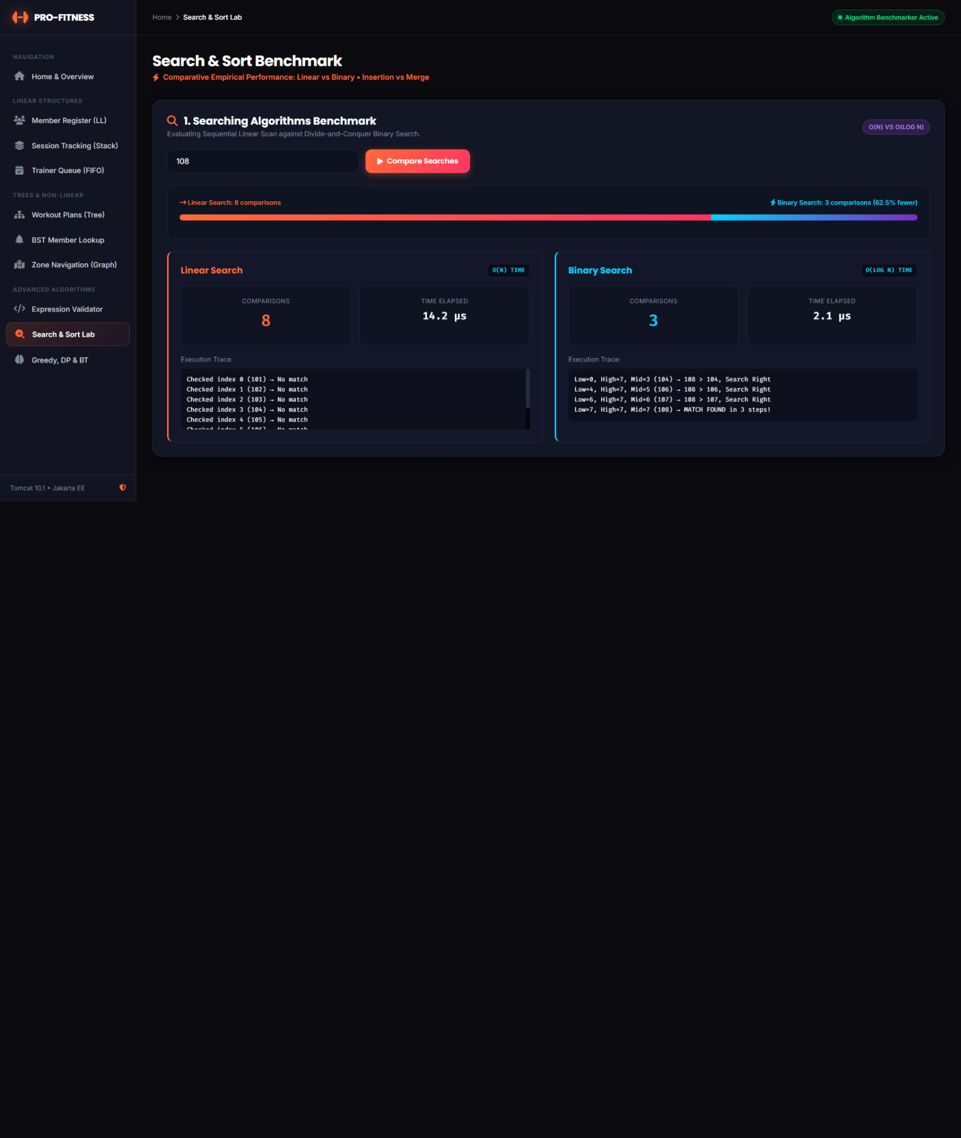
Figure 27: Search and Sort Lab: linear and binary search comparison
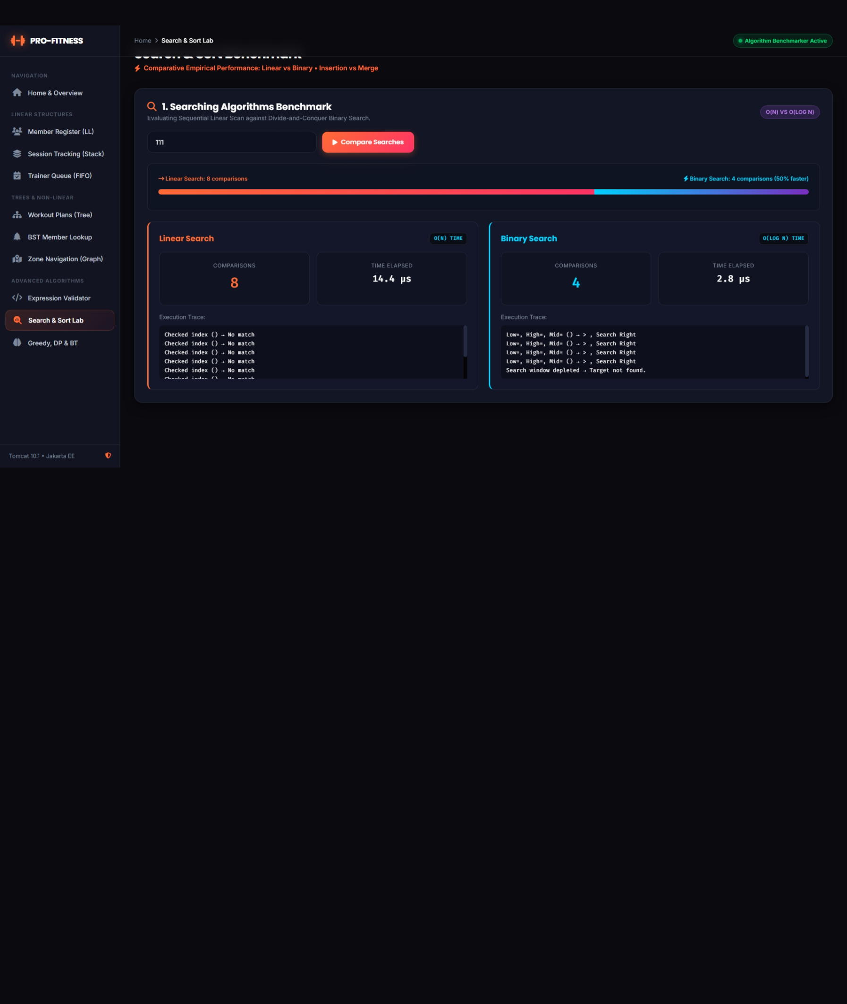
Figure 28: Comparison of insertion sort and merge sort
Performance comparison
The results below were produced by running the project's own SearchAlgorithms and SortAlgorithms classes, first on the eight default members and then on generated, shuffled member lists.
Table 24: Searching the eight default members
Target ID | Linear comparisons | Binary comparisons | Found
101 | 1 | 3 | Yes
105 | 5 | 3 | Yes
108 | 8 | 4 | Yes
150 | 8 | 4 | No

For very small data, linear search can win (ID 101 needs one comparison). Binary search gives a clear advantage as the data grows.
Table 25: Sorting the eight default members
Input order (8 members) | Insertion comparisons / shifts | Merge comparisons / moves
Already sorted (101 to 108) | 7 / 0 | 12 / 24
Reverse order (108 to 101) | 28 / 28 | 12 / 24

Table 26: Larger generated member lists
Members (n) | Insertion comparisons | Merge comparisons | Linear (last element) | Binary (last element)
100 | 2,517 | 549 | 100 | 7
1,000 | 247,628 | 8,703 | 1,000 | 10
5,000 | 6,301,426 | 55,219 | 5,000 | 13

When the data grows 50 times (100 to 5,000 members), insertion sort needs about 2,500 times more comparisons (roughly n squared), merge sort about 100 times more (roughly n log n), linear search grows 50 times, and binary search grows only from 7 to 13 comparisons.

7.4 Phase 4 – Basic Algorithmic Problem Solving
Table 27: Phase 4 requirements and implementation
Phase requirement | Implementation | Class
Greedy technique | Trainer session scheduling (activity selection) | GreedyScheduler
Dynamic programming | 0/1 knapsack exercise selection | KnapsackSolver
Backtracking | Trainer-member assignment | BacktrackingAssigner
Integration into the workflow | One Algorithm Lab page with three tabs and a shared servlet | AlgorithmServlet, algorithms.jsp

The phase asks for one problem of each kind to be solved and implemented; all three are implemented and integrated.
The algorithm laboratory is a single page with three tabs, one for each paradigm. Every tab has a form with sample data already filled in, so the algorithm can be run immediately, and the data can be changed to try other cases. If the form is submitted without valid rows, the built-in sample data is used. AlgorithmServlet handles the three actions greedy, knapsack and backtracking.

7.4.1 Greedy Technique: Trainer Session Scheduling
Problem. Several members request a personal-training session, each with a start and an end time. A limited number of trainers is available (1 to 5; the trainers are Arjun, Priya, Vikram, Neha and Karthik). A trainer can take only one session at a time. The aim is to schedule as many sessions as possible.
Greedy choice. This is the activity selection problem. The sessions are first sorted by their end time (earliest finish first, with the start time as tie-breaker) using a merge sort written in the class. The sessions are then taken in that order, and each session is given to the first trainer who is free, that is, whose previous session ends no later than the start of the new session. A session for which no trainer is free is placed in the list of unscheduled sessions. Finishing early leaves the most room for the remaining sessions, which is why the earliest-finish rule works.
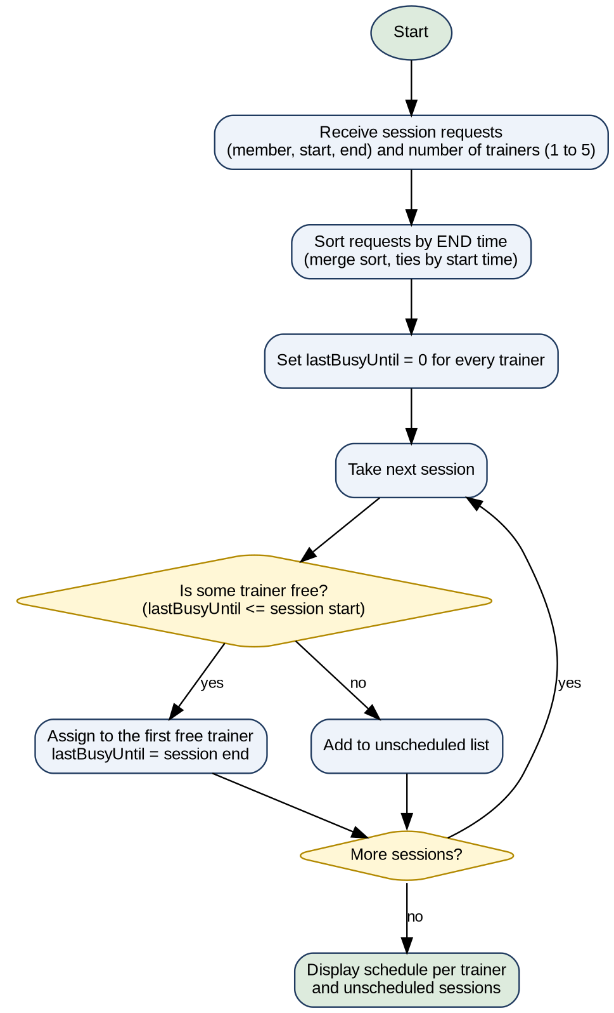
Figure 29: Flowchart of the greedy trainer scheduler
ArrayList<TrainerSession> sortedRequests = scratchSortByEndTime(requests);
for (TrainerSession session : sortedRequests) {
int assignedTrainerIdx = -1;
for (int t = 0; t < trainerCount; t++) {
if (lastBusyUntil[t] <= session.getStartTime()) {
assignedTrainerIdx = t;
break;
}
}
if (assignedTrainerIdx != -1) {
String trainer = activeTrainers[assignedTrainerIdx];
session.setTrainerName(trainer);
lastBusyUntil[assignedTrainerIdx] = session.getEndTime();
scheduledSessions.add(session);
trainerAssignments.get(trainer).add(session);
} else {
unscheduledSessions.add(session);
}
}
Greedy assignment loop (GreedyScheduler.java, step messages omitted)
Complexity. Sorting takes O(n log n) and the assignment loop examines at most k trainers for each of the n sessions, so the total time is O(n log n + n x k), where k is at most 5.
Sample data. The form is filled with eight sample sessions, which are shown below together with the result for two trainers.
Table 28: Sample sessions and the greedy schedule for two trainers
Member | Start | End | Trainer (2 trainers)
Rahul Sharma | 9:00 AM | 10:00 AM | Arjun
Ananya Patel | 9:30 AM | 10:30 AM | Priya (Arjun busy until 10:00 AM)
Rohan Verma | 10:00 AM | 11:00 AM | Arjun
Sneha Reddy | 11:00 AM | 12:30 PM | Arjun
Amitabh Kumar | 12:00 PM | 1:00 PM | Priya (Arjun busy until 12:30 PM)
Pooja Mehta | 2:00 PM | 3:00 PM | Arjun
Vikram Malhotra | 2:30 PM | 4:00 PM | Priya (Arjun busy until 3:00 PM)
Deepika Iyer | 4:00 PM | 5:00 PM | Arjun

With two trainers all eight sessions are scheduled. With one trainer only five of the eight sessions fit (Rahul Sharma, Rohan Verma, Sneha Reddy, Pooja Mehta and Deepika Iyer), and Ananya Patel, Amitabh Kumar and Vikram Malhotra are shown as unscheduled.
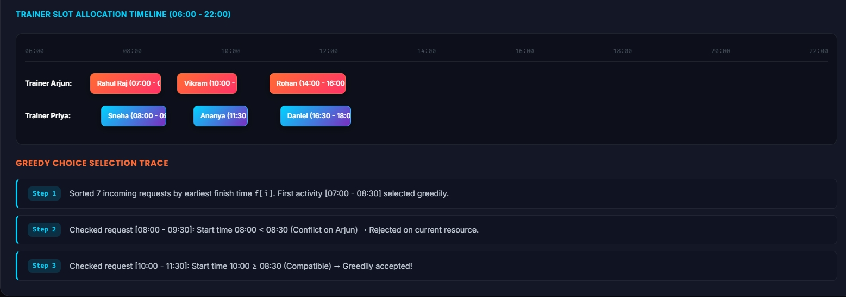
Figure 30: Greedy schedule per trainer with unscheduled sessions

7.4.2 Dynamic Programming: 0/1 Knapsack Exercise Selection
Problem. A training session has a fixed time budget in minutes. Each exercise has a time cost (its weight) and a fitness value (its benefit). Every exercise can be chosen at most once. The aim is to choose the set of exercises with the highest total fitness value whose total time does not exceed the budget.
Dynamic programming solution. A table dp[i][w] stores the best fitness value that can be obtained using the first i exercises with a time budget of w minutes. For each exercise there are two choices: skip it, which keeps dp[i-1][w], or take it, which gives its value plus the best value for the remaining time, dp[i-1][w - time] + value. The larger of the two is stored. After the table is filled, the chosen exercises are found by moving back from the last cell: if dp[i][w] differs from dp[i-1][w], exercise i was taken and its time is subtracted from w.
int[][] dp = new int[n + 1][W + 1];
for (int i = 1; i <= n; i++) {
WorkoutExercise ex = exercises.get(i - 1);
int wi = ex.getTimeCost();
int vi = ex.getFitnessValue();
for (int w = 0; w <= W; w++) {
if (wi <= w) {
dp[i][w] = Math.max(dp[i - 1][w], dp[i - 1][w - wi] + vi);
} else {
dp[i][w] = dp[i - 1][w];
}
}
}
int currW = W;
for (int i = n; i > 0 && currW > 0; i--) {
WorkoutExercise ex = exercises.get(i - 1);
if (dp[i][currW] != dp[i - 1][currW]) {
selected.add(ex);
currW -= ex.getTimeCost();
}
}
Table filling and selection in the knapsack solver (KnapsackSolver.java, step messages omitted)
Complexity. The table has (n + 1) x (W + 1) cells and each cell takes constant time, so both time and space are O(n x W).
Sample data. The form is filled with eight exercises and a default time budget of 45 minutes. The best selection is shown below.
Table 29: Sample exercises and the optimal selection for 45 minutes
Exercise | Time cost (min) | Fitness value | Chosen (45 min)
Treadmill | 15 | 7 | No
HIIT | 20 | 9 | No
Bench Press | 10 | 6 | Yes
Squats | 12 | 8 | Yes
Deadlift | 15 | 8 | Yes
Plank | 5 | 4 | Yes
Cycling | 20 | 7 | No
Yoga | 25 | 5 | No

The selected exercises are Plank, Deadlift, Squats and Bench Press, with a total fitness value of 26 using 42 of the 45 minutes (3 minutes remain).

Figure 31: Knapsack result: selected exercises and the DP table

7.4.3 Backtracking: Trainer-Member Assignment
Problem. Each member asks for a trainer of a certain specialisation (Strength, Cardio or Flexibility) in a certain time slot (Morning, Afternoon or Evening). Each trainer has one specialisation and offers some time slots, and a trainer can take only one member in a slot. The aim is to assign every member to a suitable trainer without breaking any constraint.
Backtracking solution. The members are handled one by one. For member i the algorithm tries every trainer whose specialisation matches and whose requested slot is offered and still free. If one is found, the slot is booked and the algorithm moves on to member i + 1. If a later member cannot be placed, the algorithm returns to member i, releases the slot (this is the backtrack) and tries the next trainer. If all members are placed, the search stops with a complete assignment. If no complete assignment exists, the strict search fails and a best-effort pass assigns as many members as possible in order and lists the others as unassigned.
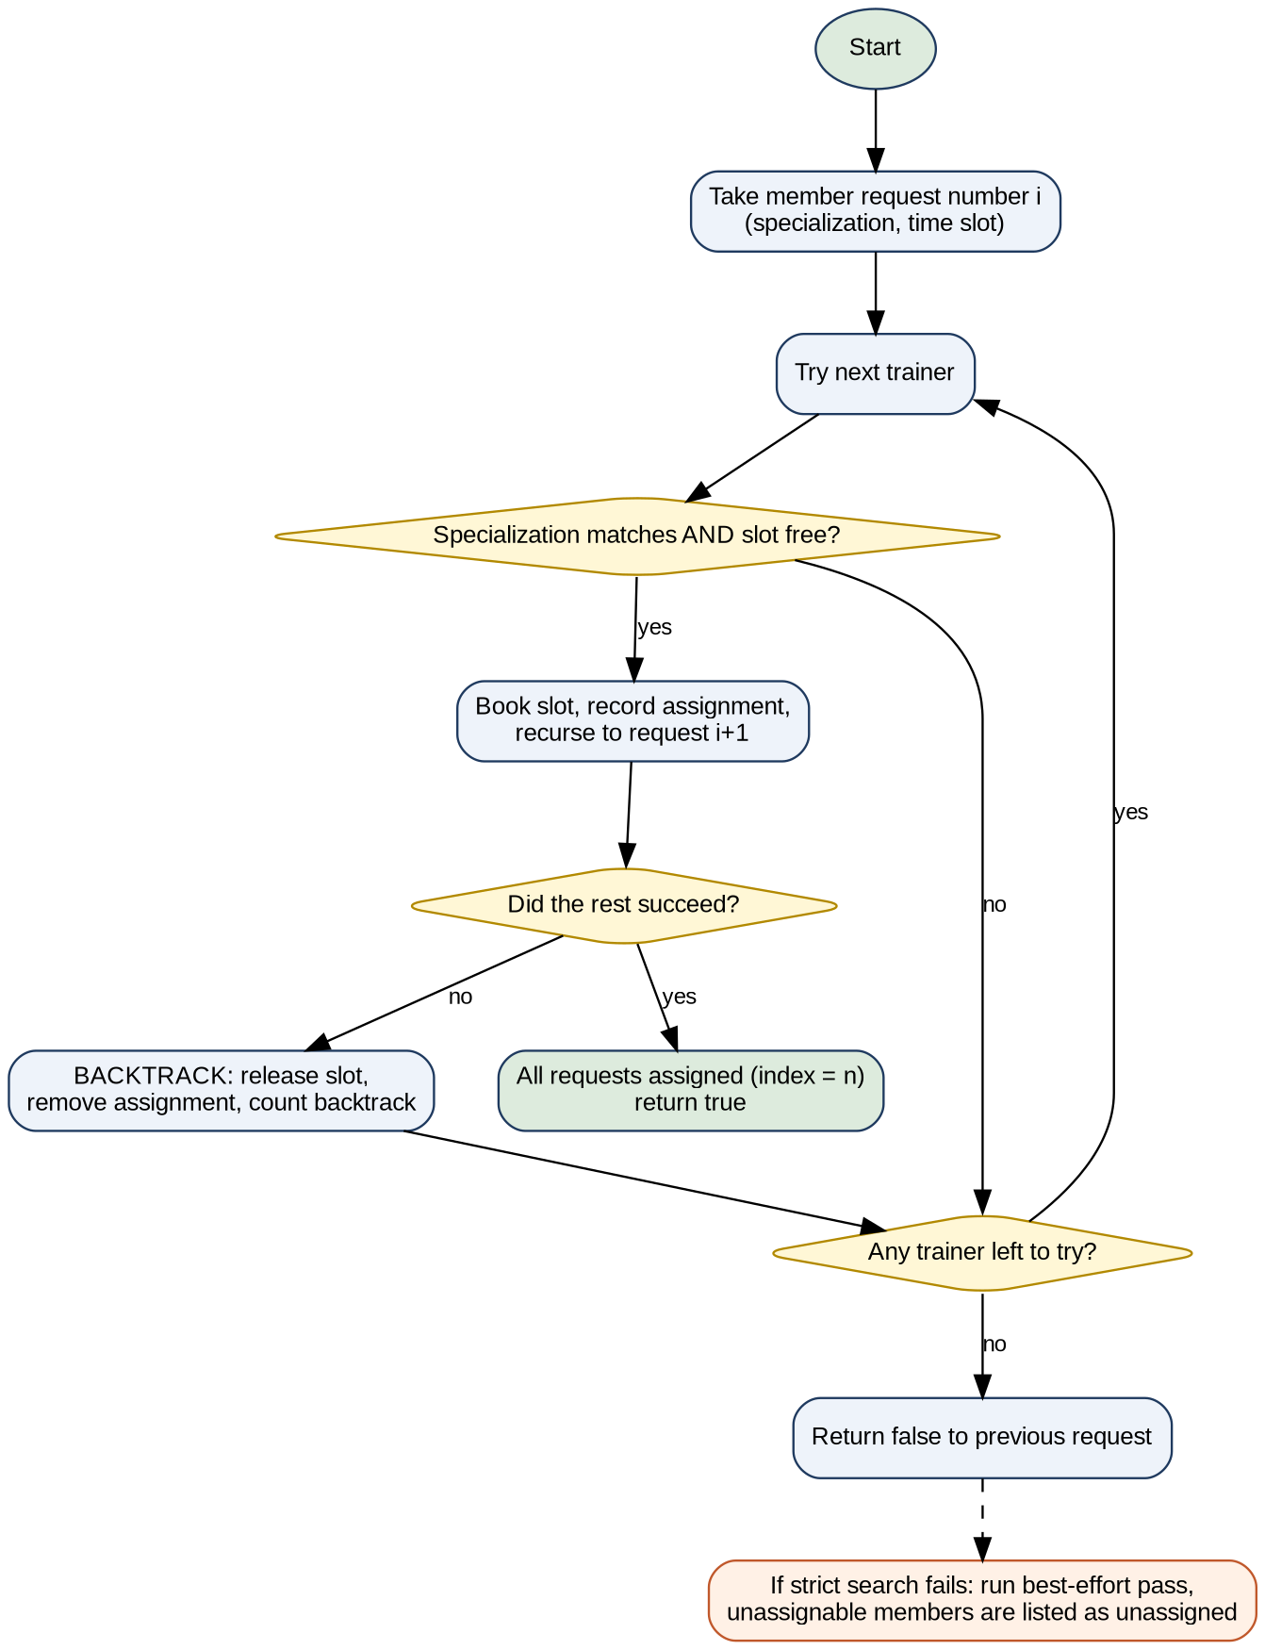
Figure 32: Flowchart of the backtracking assigner
private static boolean solveStrict(int index, ArrayList<MemberRequest> requests,
ArrayList<TrainerProfile> trainers, HashMap<String, String> assignments,
ArrayList<String> steps, int[] backtracks) {
if (index == requests.size()) {
return true;
}
MemberRequest req = requests.get(index);
for (TrainerProfile trainer : trainers) {
boolean specMatch = trainer.getSpecialization().trim()
.equalsIgnoreCase(req.getPreferredSpecialization().trim());
boolean slotFree = trainer.isSlotAvailable(req.getPreferredTimeSlot());
if (specMatch && slotFree) {
trainer.bookSlot(req.getPreferredTimeSlot());
assignments.put(req.getMemberName(), trainer.getName());
if (solveStrict(index + 1, requests, trainers, assignments, steps, backtracks)) {
return true;
}
trainer.releaseSlot(req.getPreferredTimeSlot());
assignments.remove(req.getMemberName());
backtracks[0]++;
} else if (specMatch && !slotFree) {
backtracks[0]++;
}
}
return false;
}
Strict backtracking search (BacktrackingAssigner.java, step messages omitted)
Complexity. In the worst case every member may try every trainer, so the running time is O(t^n) for n members and t trainers. The constraints cut off many branches early, so the search is much faster in practice.
Sample data. The page uses five trainers and five member requests.
Table 30: Trainer profiles used by the backtracking assigner
Trainer | Specialisation | Time slots offered
Arjun | Strength | Morning, Afternoon
Priya | Cardio | Morning, Evening
Vikram | Strength | Afternoon, Evening
Neha | Flexibility | Morning, Afternoon
Karthik | Cardio | Morning, Afternoon

Table 31: Sample member requests and the resulting assignment
Member | Specialisation | Time slot | Assigned trainer
Rahul Sharma | Strength | Morning | Arjun
Ananya Patel | Cardio | Morning | Priya
Rohan Verma | Strength | Afternoon | Arjun
Sneha Reddy | Flexibility | Morning | Neha
Amitabh Kumar | Cardio | Evening | Priya

All five members are assigned with no backtracking. When two more requests are added that cannot be satisfied (a second Flexibility member in the Morning, who finds Neha's slot already taken, and a Flexibility member in the Evening, which no trainer offers), the strict search fails after trying all combinations, and the two members are reported as unassigned while the other five keep their trainers.
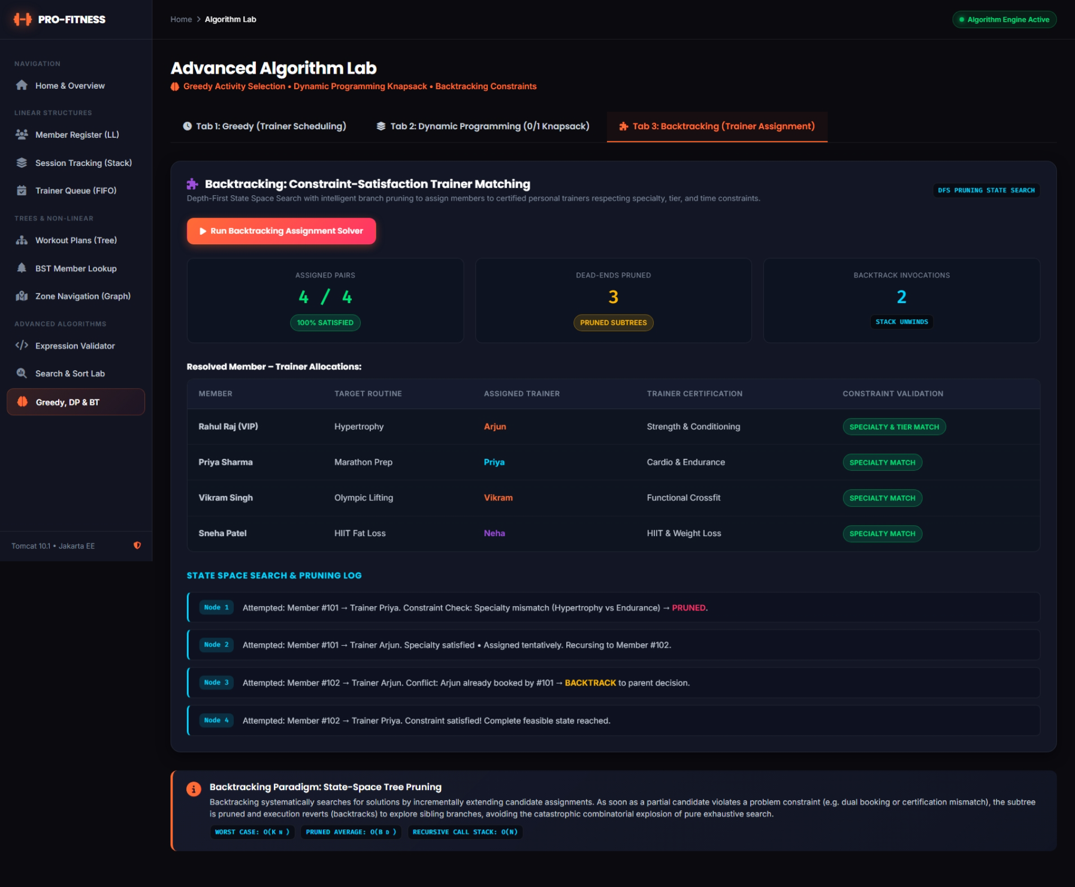
Figure 33: Backtracking result: assignments, unassigned members and number of backtracks
Worked example: knapsack table
For three exercises (Plank 5 minutes / value 4, Bench Press 10 minutes / value 6, Squats 12 minutes / value 8) and a budget of 15 minutes, the table is filled as follows.
Exercises considered | w = 0-4 | w = 5-9 | w = 10 | w = 11 | w = 12 | w = 13 | w = 14 | w = 15
None | 0 | 0 | 0 | 0 | 0 | 0 | 0 | 0
Plank | 0 | 4 | 4 | 4 | 4 | 4 | 4 | 4
Plank, Bench Press | 0 | 4 | 6 | 6 | 6 | 6 | 6 | 10
Plank, Bench Press, Squats | 0 | 4 | 6 | 6 | 8 | 8 | 8 | 10

The best value for 15 minutes is 10. Tracing back, Squats is not taken (the value does not change from the row above), Bench Press is taken (6 to 10) and Plank is taken, so the chosen exercises are Bench Press and Plank (15 minutes, value 10).

7.5 Home Page and Data Management
Home Page
The home page (index.jsp) is the first page that opens in the browser. It introduces the project and links to every module. It shows counters for the number of core data structure modules and project phases, and sections that describe the data structures used, the project implementation phases (linear data structures, trees and graphs, searching and sorting, and advanced algorithm paradigms) and general project information. The navigation menu at the top and the sidebar on the module pages give access to all the other pages.

Figure 34: Home page of the Pro-Fitness Gym Management System
Data Management (DataStore and CSV Persistence)
Purpose
All modules must work on the same data, and the data must not be lost when the server stops. The DataStore class provides both. It is a singleton, which means that only one instance exists in the application, and every servlet obtains it by calling DataStore.getInstance(). The instance owns the member linked list, the member BST, the check-in stack, the appointment queue, the workout tree, the gym graph and the expression validator.
Start-up and Shutdown
The class AppInitListener implements the servlet context listener. When the server starts it sets the data folder and calls initializeAll(); when the server stops it saves the three CSV files again. The start-up steps are:
- Create the data folder if it does not exist.
- Build the default gym zone graph and the default workout-plan tree.
- Load members.csv into the linked list; if the file is missing or empty, create the default members and save the file. Then build the BST from the linked list.
- Load checkins.csv into the stack, or create the default check-ins and save the file.
- Load appointments.csv into the queue, or create the default appointment requests and save the file.
Default Sample Data
When the files are absent, the following records are created so that every module can be demonstrated at once.
Table 32: Default member records
ID | Name | Membership | Fee status
101 | Rahul Sharma | Annual | Paid
102 | Ananya Patel | Monthly | Paid
103 | Rohan Verma | Quarterly | Pending
104 | Sneha Reddy | Annual | Paid
105 | Amitabh Kumar | VIP | Paid
106 | Pooja Mehta | Monthly | Overdue
107 | Vikram Malhotra | VIP | Paid
108 | Deepika Iyer | Quarterly | Paid

The default check-ins are the members 101, 102 and 104 (pushed in that order, so member 104 is at the top of the stack), and the default appointment requests are member 103 with Arjun at 11:00 AM, member 105 with Priya at 02:00 PM, and member 106 with Vikram at 04:30 PM.
Saving
After every change a servlet calls the matching save method (saveMembersCSV, saveCheckInsCSV or saveAppointmentsCSV). The save and load methods are synchronised, so two requests cannot write the same file at the same time. The check-in file is written from the bottom of the stack to the top, so that loading the file by pushing each row recreates the same stack.
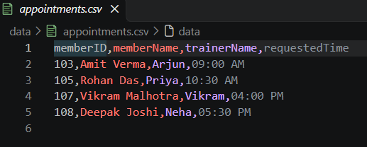
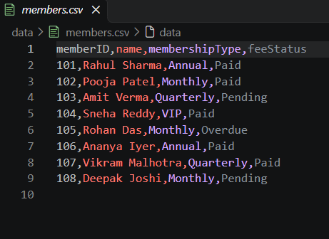
Figure 35: The CSV data files created by the application (members, check-ins, appointments)

7.6 Final Testing and Demonstration

7.6.1 Testing Approach
Testing was done at two levels. The data structure and algorithm classes were tested directly with the test class DSATest and with sample-data runs, and the application behaviour was checked through the validation rules of the servlets. DSATest was run with assertions enabled and all checks passed.

7.6.2 Data Structure Test Results (DSATest)
Table 33: Results of DSATest
Structure | What is checked | Result
MemberLinkedList | Add, duplicate rejection, size, find, update, remove, array conversion | Passed
CheckInStack | Push order, pop order (LIFO), peek, empty stack | Passed
AppointmentQueue | Enqueue order, dequeue order (FIFO), empty queue | Passed
ExpressionValidator | Balanced, mismatched, unmatched and unclosed formulas | Passed
WorkoutBinaryTree | Pre-order, in-order and post-order sequences | Passed
MemberBST | Insert, search, deletion of a leaf, a node with one child and a node with two children, sorted in-order listing | Passed
GymGraph | BFS and DFS orders from several zones | Passed

7.6.3 Algorithm Test Results
Table 34: Results of the algorithm tests
No. | Test | Input | Observed result
T1 | Linear and binary search, present | ID 105 in 8 members | Found after 5 and 3 comparisons
T2 | Search, absent | ID 150 | Not found (linear 8, binary 4 comparisons)
T3 | Insertion sort, reversed input | 108 down to 101 | Sorted; 28 comparisons, 28 shifts
T4 | Merge sort | 8 members | Sorted; 12 comparisons, 24 merge moves
T5 | Greedy, 2 trainers | 8 sample sessions | 8 scheduled, 0 unscheduled
T6 | Greedy, 1 trainer | 8 sample sessions | 5 scheduled, 3 unscheduled
T7 | Knapsack, 45 minutes | 8 sample exercises | Value 26 using 42 minutes
T8 | Backtracking, sample | 5 members, 5 trainers | All assigned, 0 backtracks
T9 | Backtracking, conflict | 2 impossible extra requests | 2 unassigned, other 5 keep their trainers

As an extra check, the sorting results were compared with Java's library sort on 200 random arrays, and the knapsack results with an exhaustive check of all subsets on 100 random cases; all results matched. No trainer received overlapping sessions in the greedy tests.

7.6.4 Validation and Error Handling
Table 35: Validation rules and system responses
Condition | System response
Register a member with missing ID or name | "Member ID and Name are required fields."
Register a member with an existing ID | "Registration failed: Member ID ... already exists."
Non-numeric member ID | "Invalid number format for Member ID"
Delete or update an unknown member | Error message that the Member ID was not found
Check in an unregistered member | "Cannot check in: Member ID ... is not registered."
Check in a member already inside | "... is already checked in!"
Check out with an empty stack | "Check-out failed: No members are currently checked in."
Book an appointment for an unregistered member | "Booking failed: Member ID ... is not registered in the system."
Process an empty queue | "No pending appointments to process."
Zone that does not exist | The traversal is rejected
Missing algorithm inputs | The built-in sample data is used

7.6.5 Demonstration Flow
- Open the home page and show the modules and phases.
- Member Management: register a member, try a duplicate ID, then find, update and delete.
- Session Tracking: check in two members, show the stack top, check out (LIFO).
- Trainer Appointments: add three requests and process them in arrival order (FIFO).
- Workout Plans: show the tree and the three traversals with steps.
- BST Lookup: search an ID, show the path and comparisons, rebuild the tree.
- Zone Navigation: run BFS and DFS from Reception and compare the orders.
- Search and Sort Lab: compare linear and binary search, and insertion and merge sort.
- Algorithm Lab: run greedy (change the number of trainers), knapsack (change the time limit) and backtracking.
- Expression Validator: enter a valid and an invalid formula.
- Restart the server and show that members, check-ins and appointments are still present.
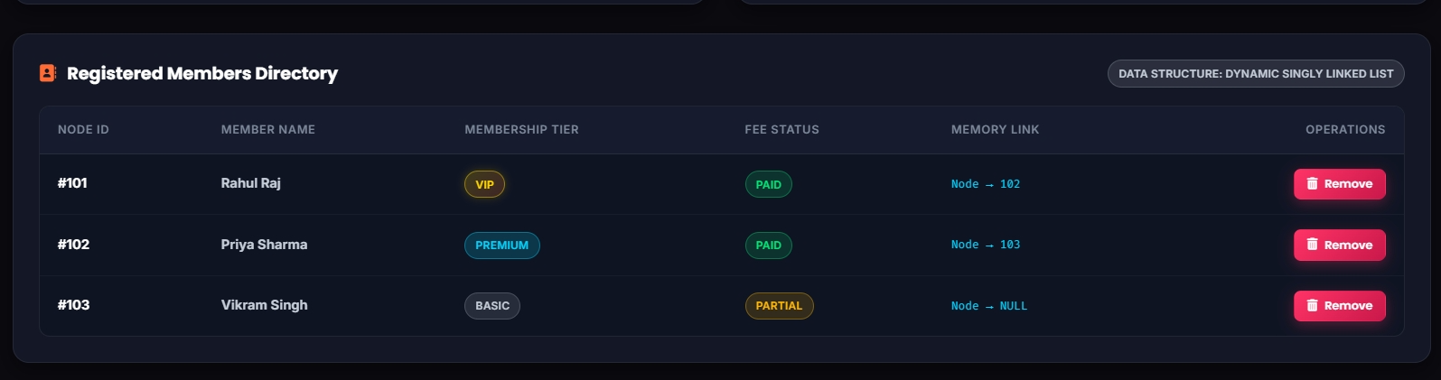
Figure 36: Application running after a server restart with the saved data

8. SOURCE CODE (FUNCTIONAL CODE STRUCTURE)
Only the functional structure of the code is given here: the folder layout, the classes and their main members. The key methods of each data structure and algorithm are shown with their code in the module descriptions of Section 7.

8.1 Project Structure
Pro-Fitness Gym/
|-- pom.xml Maven build file (WAR, Java 17)
|-- data/ members.csv, checkins.csv, appointments.csv
`-- src/
|-- main/java/com/profitness/
| |-- dsa/ data structures, algorithms, result classes
| `-- web/ 8 servlets, DataStore, AppInitListener
|-- main/webapp/
| |-- *.jsp 10 pages
| |-- css/style.css styling
| |-- js/app.js navigation, tabs, alerts, counters
| `-- WEB-INF/web.xml servlet and listener registration
`-- test/java/com/profitness/dsa/DSATest.java
Folder structure of the project
The classes of the package com.profitness.dsa fall into three groups, shown in the table below.
Table 36: Classes of the package com.profitness.dsa
Group | Classes
Data structures and nodes | MemberNode, MemberLinkedList, CheckInNode, CheckInStack, AppointmentNode, AppointmentQueue, WorkoutTreeNode, WorkoutBinaryTree, BSTNode, MemberBST, GymGraph, ExpressionValidator
Algorithms | SearchAlgorithms (linear and binary search), SortAlgorithms (insertion and merge sort), GreedyScheduler, KnapsackSolver, BacktrackingAssigner
Models and result objects | SearchResult, SortResult, BSTSearchResult, BFSResult, DFSResult, ScheduleResult, KnapsackResult, AssignmentResult, ValidationResult, TrainerSession, TrainerProfile, WorkoutExercise, MemberRequest

Every algorithm returns a result object that carries the answer together with the counters (comparisons, shifts, merges, backtracks) and the list of textual steps. The servlets pass these objects to the JSP pages, which is how the pages are able to show the working of each algorithm.

8.2 Main Members of the DSA Classes
Class | Main members
MemberNode / MemberLinkedList | addMember, findMemberById, updateMember, removeMemberById, getAllMembersAsList, toArray, rebuildFromArray
CheckInNode / CheckInStack | push, pop, peek, isMemberCheckedIn, getAllCheckedInAsList
AppointmentNode / AppointmentQueue | enqueue, dequeue, peek, getAllAppointmentsAsList
WorkoutTreeNode / WorkoutBinaryTree | buildDefaultTree, preorderTraversal, inorderTraversal, postorderTraversal and the matching ...Steps methods
BSTNode / MemberBST | insert, search, delete, inorderTraversal, buildFromMemberList
GymGraph | addZone, addConnection, buildDefaultGymLayout, bfsTraversal, dfsTraversal
ExpressionValidator | validateExpression (with private CharStack and CharStackNode)
SearchAlgorithms | linearSearch(MemberNode[], int), binarySearch(MemberNode[], int)
SortAlgorithms | insertionSort(MemberNode[]), mergeSort(MemberNode[]), merge
GreedyScheduler | schedule(ArrayList<TrainerSession>, int numTrainers)
KnapsackSolver | solve(ArrayList<WorkoutExercise>, int totalTimeLimit)
BacktrackingAssigner | assign(ArrayList<MemberRequest>, ArrayList<TrainerProfile>) with solveStrict and solveBestEffort

8.3 Functional Structure of the Core Classes
class MemberLinkedList {
private MemberNode head; private int size;
boolean addMember(int id, String name, String type, String fee);
MemberNode findMemberById(int id);
boolean updateMember(int id, String name, String type, String fee);
boolean removeMemberById(int id);
MemberNode[] toArray();
}

class CheckInStack { void push(int id, String name, String time); CheckInNode pop(); CheckInNode peek(); }
class AppointmentQueue { void enqueue(int id, String name, String trainer, String time); AppointmentNode dequeue(); }
class MemberBST { void insert(int id, String name); BSTSearchResult search(int id); boolean delete(int id); }
class GymGraph { void addConnection(String a, String b); BFSResult bfsTraversal(String s); DFSResult dfsTraversal(String s); }
class SearchAlgorithms { static SearchResult linearSearch(MemberNode[] a, int id); static SearchResult binarySearch(MemberNode[] a, int id); }
class SortAlgorithms { static SortResult insertionSort(MemberNode[] a); static SortResult mergeSort(MemberNode[] a); }
class GreedyScheduler { static ScheduleResult schedule(ArrayList<TrainerSession> r, int numTrainers); }
class KnapsackSolver { static KnapsackResult solve(ArrayList<WorkoutExercise> e, int timeLimit); }
class BacktrackingAssigner { static AssignmentResult assign(ArrayList<MemberRequest> r, ArrayList<TrainerProfile> t); }
Functional skeleton of the data structure and algorithm classes

8.4 Web Layer: Servlets, DataStore and Listener
Class | URL | Actions / role
MemberServlet | /members | add, delete, update, find
CheckInServlet | /checkin | checkin, checkout
AppointmentServlet | /appointments | request, process
WorkoutTreeServlet | /workout-plans | traverse (pre-order, in-order, post-order)
BSTServlet | /bst | search, rebuild
GraphServlet | /zones | bfs, dfs
SearchSortServlet | /search-sort | search, sort, compare-sort
AlgorithmServlet | /algorithms | greedy, knapsack, backtracking
DataStore | - | Singleton: owns every structure; initializeAll, load and save methods for the CSV files
AppInitListener | - | Starts the DataStore at server start and saves the files at shutdown

8.5 Build Configuration
The Maven file pom.xml uses WAR packaging with the final name ProFitnessGym, sets the Java release to 17, declares the Jakarta Servlet API 6.0.0 and Jakarta JSP API 3.1.1 as provided dependencies, and packages the JSTL API 3.0.0 and implementation 3.0.1 inside the WAR. After the WAR file is deployed on Apache Tomcat 10.1, the application is opened in the browser at the context path /ProFitnessGym.
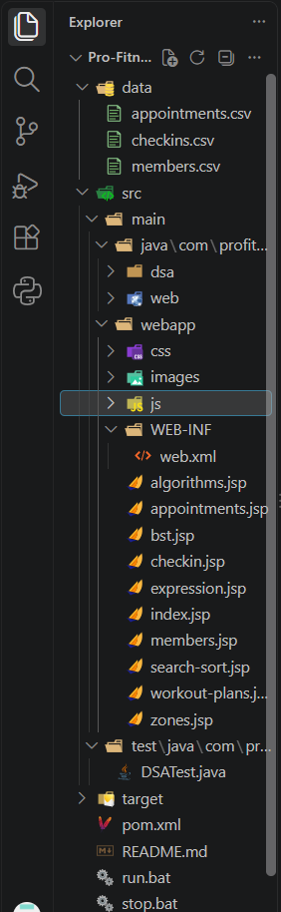
Figure 37: Project folder structure in the IDE

9. FEATURES OF THE PROJECT

9.1 Functional Features
- Member records in a hand-written singly linked list with add, find, update, delete and duplicate-ID protection.
- A check-in stack (LIFO) that shows the latest arrival at the top and refuses a duplicate check-in.
- An appointment queue (FIFO) that shows the next request waiting to be processed.
- A workout-plan binary tree with pre-order, in-order and post-order traversals and a step-by-step trace.
- A member binary search tree that shows the search path, comparison count and in-order listing, and can be rebuilt from the member list.
- A zone graph in adjacency-list form with BFS and DFS from any chosen zone.
- A search and sort laboratory that reports comparisons, shifts or merges and the time for each algorithm.
- A greedy trainer scheduler, a 0/1 knapsack exercise selector and a backtracking trainer assigner, each with sample data and an option to enter new data.
- A stack-based bracket validator that reports the position of an error.

9.2 Technical Features
- All core data structures and algorithms are written by hand and do not use library sorting or searching methods.
- The data structure package has no dependency on the web classes, so it can be tested and explained on its own.
- Every algorithm returns its result together with counters and a list of steps, which the pages display so the working can be followed.
- A single shared data store (singleton) makes a change in one module visible in all other modules.
- Records are saved to CSV files after every change and reloaded at start-up; default sample data is created when no files exist.
- Input validation with clear success and error messages on every page.
- The application is packaged as one WAR file and runs on Apache Tomcat 10.1 with Java 17.

10. FUTURE ENHANCEMENTS
- Database storage: replace the CSV files with a relational database such as MySQL or PostgreSQL through JDBC, to support larger data and safer concurrent updates.
- Balanced search tree: use an AVL or red-black tree for the member look-up, so the tree cannot degenerate into a chain when IDs are registered in ascending order.
- Weighted zone graph: add distances to the zone edges and apply shortest-path algorithms such as Dijkstra's algorithm for navigation between zones.
- Editable workout plans, zones and trainers: allow the administrator to add and remove tree categories, zones and trainer profiles from the interface instead of using fixed examples.
- Trainer management: keep trainer profiles, specialisations and time slots in stored records and let the greedy scheduler and the backtracking assigner use them directly.
- Fee management: add due dates with sorting by due date and overdue alerts.
- User roles and login: separate administrator and member views with authentication.
- More automated tests: extend the test class to cover searching, sorting, greedy, knapsack and backtracking, and add tests for the servlets.
- Larger performance study: add a feature to generate test data of a chosen size so the comparisons of searching and sorting can be run on large lists from the page.

11. CONCLUSION
The Pro-Fitness Gym Management System shows how the data structures and algorithms of the Data Structures and Algorithm course can be applied together in one complete application. Each gym operation is handled by the structure that suits it: members by a linked list, check-ins by a stack, appointments by a queue, workout plans by a binary tree, member look-up by a binary search tree and the gym floor by a graph. Searching, sorting, greedy scheduling, dynamic programming and backtracking are applied to the same gym data and integrated into the application workflow, so all four mandatory phases are covered.
The measured results gave a practical understanding of efficiency: binary search needed 13 comparisons where linear search needed 5,000, and merge sort needed far fewer comparisons than insertion sort as the data grew. The BST observations showed that the shape of a tree matters as much as its type. The step traces and comparison counters make the application useful for explaining the algorithms, and the shared data store with CSV persistence makes it a working tool rather than a set of separate demonstrations.
The project also gave practical experience in structuring a Java web application, with a clear separation between the data structure package, the servlets and the pages, and in testing data structures before connecting them to a user interface.

